Currency Note detection for blind Assistance using Deep Learning



By

Muhammad Adil Saeed
Maalik Ashtar

Department of Computer Science

Govt Akhter Nawaz Khan (S) Degree College KTS Haripur

May, 2025

Currency Note detection for blind Assistance using Deep Learning



By

Muhammad Adil Saeed, Maalik Ashtar
CS-21406, 21418

Supervised by

Mr. Syed Shahid Gillani

Department of Computer Science

University of Haripur

May, 2025
Currency Note detection for blind Assistance using Deep Learning



By

Muhammad Adil Saeed, Maalik Ashtar

A Dissertation Submitted in Partial Fulfilment for the Degree of

BACHELORS

IN

COMPUTER SCIENCE

Department of Computer Science

University of Haripur

May, 2025
Currency Note detection for blind Assistance using Deep Learning

By

Muhammad Adil Saeed, Maalik Ashtar

CERTIFICATE

A THESIS SUBMITTED IN THE PARTIAL FULFILMENT OF THE
REQUIRMENTS FOR THE DEGREE OF BACHELORS

IN COMPUTER SCIENCE

We accept this dissertation as conforming to the required standards

Mr.

External Examiner

Mr. Syed Shahid Gillani
Final Year Project Coordinator

Department of Computer Science

University of Haripur

May, 2025

Declaration

I hereby declare that this dissertation is neither as a whole or part thereof has been copied out from any source. If any part of this thesis is proved to be copied or found to be a report of some other, we shall bear the consequences. No portion of this work presented in the thesis has been submitted in support of any application from any other degree of qualification or any other university or any other institute of learning.
I further declare that this research and all the associated documents with this, reports and all records are submitted as a partial requirement of the degree of Bachelor in Computer Science. We understand and transfer copyrights for these materials to the University of Haripur and we will not sale this research and documents for getting any financial gains. It is further declared that I developed this and also this thesis is entirely based on our personal efforts made under the sincere guidance of the project supervisor Syed Shahid Gillani, Govt. Akhter Nawaz Khan [Shaheed] Haripur.

Muhammed Adil Saeed (21406): ___________________
Maalik Ashtar (21418): ______________________

Dedication

Our beloved parents and sincere and encouraging teachers. Especially Dr. Abid Ali, who guided us and struggled with us in our journey through this project.

Acknowledgements

Allah is very kind and merciful. His benevolence and blessings enabled us to accomplish this task. We express our heartfelt gratitude to our parents and family for their prayers, moral support and sincere wishes for the completion of our work.
We would thanks to almighty Allah who gives us opportunity to take the right path and help us in every problem during the project. We would like to express our sincere and humble gratitude to Almighty, whose help, guidance and blessings have been a real source of all our achievements in our life. We would like to thank our Supervisor Mr. Syed Shahid Gillani, whose suggestions, encouragement and guidance is a real source of inspiration for us throughout the entire timeline of our project. Our heartfelt gratitude goes to our families for their unflagging love and supporting us spiritually throughout our life; this dissertation would have been simply impossible without them.

Muhammad Adil Saeed, Maalik Ashtar

Abstract

People with visual impairments often face difficulties in identifying currency notes. This project aims to develop a desktop-based deep learning application that assists visually impaired individuals in recognizing and detecting the denomination of different Pakistani currency notes. The user interacts with the application through voice commands. When the user gives a voice command to start detection, the application activates the laptop’s webcam and captures an image of the currency note. A deep learning model processes the image to identify the denomination, which is then announced to the user using text-to-speech technology.
The application uses speech-to-text conversion to understand user commands and text-to-speech conversion to deliver the results audibly. OpenCV is used for image processing and for currency detection we used YOLOv5, the deep learning model is trained using Google Colab Pro. The graphical user interface (GUI) is developed using Python’s Tkinter library, providing an accessible and user-friendly experience. The application is designed to automatically capture and process the image without requiring manual input, making it easy to use for visually impaired individuals.

Table of Contents

CHAPTER 1 1
INTRODUCTION 1
1.1. Introduction 2
1.2. Problem Definition 3
1.3. Nature of the problem 3
1.3.1.High-Cost-of-Existing-Solutions 3
1.3.2.Complex-Usage-Requirements 3
1.3.3.Limited-Availability 3
1.3.4.Delayed-Response-Time 3
1.3.5.Increased-Workload-and-Maintenance 4
1.4. Objectives of the Project 4
1.4.1Develop-a-Real-Time-Currency-Detection-System 4
1.4.2Design-a-User-Friendly-Graphical-Interface 4
1.4.3Integrate-Voice-Command-Functionality 4
1.4.4Provide-Audio-Feedback 4
1.4.5Ensure-Offline-Functionality 4
1.5. Project Organization 4
1.6. Outputs from the Project 5
1.6.1 Desktop-Based Currency Detection Application using deep learning model: 5
1.6.2Currency-Recognition-Model-and-Dataset: 5
1.6.3Voice-Command-and-Response-System: 5
1.6.1Project-Documentation: 5
1.7 Significance of study 5
1.8 Organization of the Thesis 5
CHAPTER 2 6
Existing Systems Analysis 6
2.1. Existing System 7
2.2. Overview of Current Systems 7
2.2.1 Color-Based Detection Using HSV: 7
2.2.2 Feature-Based Recognition: 7
2.2.3 Neural Network Recognition for Bangladeshi Currency: 7
2.2.4 Texture Analysis with Markov Models and Ensemble Neural Networks: 8
2.2.5 Single Shot MultiBox Detector (SSD): 8
2.2.6 CNN for Folded Banknotes: 8
2.2.7 SURF-Based Recognition for US Banknotes: 8
2.2.8 Free-Form Deformation (FFD) for Low-Quality Images: 8
2.2.9 Deep Neural Networks with Data Augmentation: 8
2.2.10 SVM for Ethiopian Banknotes: 8
2.3. Limitations of Existing Systems 9
2.3.1 Absence of Pakistani Currency Detection: 9
2.3.2 Unavailability of Pakistani Currency Dataset: 9
2.3.4 Inadequate Output for Accessibility: 9
2.3.5 Poor Real-Time Performance: 9
Chapter 3 10
Proposed System 10
3.1. Feasibility Study 11
3.1.1 Technical Feasibility: 11
3.1.2 Economic Feasibility: 12
3.2. Functional Requirements 12
3.2.1 Real-Time Currency Detection: 12
3.2.2 Currency Detection Model: 12
3.2.3 Text-to-Speech (TTS) Output: 12
3.2.4. Voice Command Integration: 12
3.3. Non-Functional Requirements 13
3.3.1 High Accuracy and Precision: 13
3.3.2 Noise Tolerance: 13
3.3.3 Real-Time Performance: 13
3.3.4 Lightweight and Efficient: 13
3.3.5 User Accessibility: 13
3.4. System Requirements 13
3.4.1 Computer/System 13
3.4.2 Internet Availability 13
3.4.3 GitHub Repository 14
3.4.4 Draw.io Software: 14
3.4.5 Microsoft Office 14
3.4.6 Library 14
3.4.7 Microsoft Visual Studio Code 14
3.4.8 Google Collaboratory 14
3.4.9 YOLOv5 14
3.4.10 Dataset 14
3.4.11 Text to Speech Engine 14
3.4.12 Basic Detection Model 14
3.5. Chosen Methodology 16
3.6. Reason for Choosing DLLC 16
3.6.1 Advantages of DLLC 17
3.7 Use-Case Diagram 18
3.8 Sequence Diagram 19
3.9 Data Flow Diagram 20
Chapter 4 21
System Implementation 21
4.1. Experimental Setup 22
4.1.1 Python version: 22
4.1.3 Draw.io: 23
4.1.4 EndNote: 23
4.1.5 Google Colaboratory: 24
4.1.6 Microsoft Word: 24
4.2. Implementation 25
4.2.1 Custom Detection Model Development: 25
4.2.2 Training Yolov5 Model: 25
4.3 Desktop Application development: 28
4.3.1 Creating GUI: 28
4.3.2 Coding Voice Output Modu2e: 28
4.3.3 Integrating the Speech-Recognition Module: 29
Chapter 5 30
Evaluation and Results 30
5.1. Testing and Validating Model: 31
5.1.1 Testing Model: 31
5.1.2 Validating model: 33
5.1.3 Evaluation Metrics: 35
Chapter 5 40
Conclusion and Future Work 40
5.1 Conclusion 41
5.2 Future Work 41
REFERENCES 42

List of Figures

Figure | Description | Page
3.1 | Basic Detection Model of YOLOv5 . . . . . . . . . . . . . . . . . . . . | 15
3.2 | Deep Learning Life Cycle (DLLC). . . . . . . . . . | 16
3.3 | Use Case Diagram. . . . . . . . . . . . . . . . . . . . . . . . . . . . . . . . . . | 18
3.4 | Sequence Diagram. . . . . . . . . . . . . . . . . . . . . . . . . .. . . . . | 19
3.5 | Data Flow Diagram. . . . . . . . . . . . . . . . . . . . . . . . . . . . . . . | 20
4.1 | Installation of Python . . . . . . . . . . . . . . . . . . . . . . . . . . . | 22
4.2 | Environment of Visual-Studio Code. . . . . . . . . . . . . . . . . . . . | 22
4.3 | Working Environment of Draw.io . . . . . . . . . . . . . . . . . . . . . | 23
4.4 | Environment of EndNote . . . . . . . . . . . . . . . . . . . . . . . . . | 23
4.5 | Environment of Google Colab. . . . . . . . . . . . . . . . . . . . . . . | 24
4.6 | Working Environment of Microsoft Word . . . . . . . . . . . . . . . . | 24
4.7 | Training Dataset . . . . . . . . . . . . . . . . . . . . . . . . . . . . . . | 25
4.8 | GitHub Repository of YOLOv5. . . . . . . . . . . . . . . . . . . . . . | 25
4.9 | YAML File for Class Labels in Dataset. . . . . . . . . . . . . . . . . . | 26
4.10 | Script for training YOLOV5 in Colab. . . . . . . . . . . . . . . . . . . | 26
4.11 | Training Process in Google Colab. . . . . . . . . . . . . . . . | 27
4.12 | Results in /train Directory. . . . . . . . . . . . . . . . . . . . . . . . . | 27
4.13 | Creating the GUI using TKinter. . . . . . . . . . . . . . . . . . . . . . . . | 28
4.14 | Code for TTS module in python. . . . .. . . . . . . . . . . . . . . . . . . . . . . . | 28
4.15 | Integrating Speech-Recognition Module. . . . . . . . . . . . . . . . . . | 29
5.1 | Model Testing Using google Colab. . . . . . . . . . . . . . . . . . | 31
5.2 | Real-Time Currency Detection Using Laptop Webcam . . . . . . . . . | 32
5.3 | Validation Batch Results. . . . . . . . . . . . . . . . . . . . . . . . . . | 34
5.4 | PR Curve . . . . . . . . . . . . . . . . . . . . . . . . . . . . . . . | 35
5.5 | PC Curve. . . . . . . . . . . . . . . . . . . . . . . . . | 36
5.6 | F1-Score and Confidence Curve. . . . . . . . . . . . . . . . . . . . . | 37
5.7 | Confusion Matrix . . . . . . . . . . . . . . . . . . . . . . . . . . . . . . . . . . | 38
5.8 | Result Graph . . . . . . . . . . . . . . . . . . . . . . . . . . . . . . | 39

List of Tables
Line1
Line2
Table | Description | Page
1.1 | Project Organization . . . . . . . . . . . . . . . . . . . . . . . . . . . . | 4

CHAPTER 1

INTRODUCTION

1.1. Introduction
According to global statistics, more than 2 billion people suffer from visual perception issues, including nearly 1 billion individuals over the age of 50 affected by conditions such as nearsightedness, farsightedness, glaucoma, cataracts, unaddressed presbyopia, and refractive errors [1]. Reports from the World Health Organization (WHO) and various medical surveys indicate that the prevalence of visual impairment has been increasing significantly and is expected to escalate further [2].
To navigate daily life, many visually impaired individuals rely on assistive aids such as white canes or guide dogs. While these tools are affordable and widely used, they often fall short in handling specific real-world scenarios. For tasks like currency recognition, such aid may not be sufficient [3]. Visually impaired individuals frequently require assistance from others to manage everyday financial transactions, which can limit their independence and place a burden on those around them. Therefore, specialized digital assistive technologies are crucial to promote independence and social inclusion for individuals with visual disabilities [4].
Currency plays a vital role in everyday interactions, and visually impaired people must also handle money for transactions and exchanges. Every country has its own currency with different denominations that vary in color, size, pattern, and shape. While tactile marks are often used to differentiate denominations, they can fade over time due to continuous use, making them unreliable [5]. In such cases, digital image processing can be an effective solution, enabling pattern detection and recognition based on visual features of the currency [6].
Machine Learning (ML), a subset of Artificial Intelligence (AI), has shown great promise in the field of object recognition. Among ML approaches, deep learning, especially convolutional neural networks (CNNs) have proven particularly effective in identifying objects in images, often with accuracy surpassing that of humans [7]. These technological advances have significantly improved multimedia applications, enhancing both processing efficiency and accuracy [8].
In the context of currency recognition, the process involves several stages: image acquisition, preprocessing, segmentation, feature extraction, and classification. These steps can be modularized or implemented as a unified pipeline for real-time detection [9].
While many solutions focus on dedicated hardware such as wearables or handheld devices, this project proposes a more accessible and cost-effective approach: a desktop-based application using a laptop's built-in webcam. Developed using Python, the application integrates OpenCV for image processing [10], a deep learning model for currency classification, and text-to-speech (TTS) functionality to verbally communicate the detected denomination. Voice commands, processed through offline speech recognition (Vosk)[11], allow hand-free interaction for users. This implementation eliminates the need for specialized hardware and leverages the widespread availability of standard laptops, ensuring greater accessibility for users with visual impairments.

1.2. Problem Definition

Visually impaired individuals face significant challenges in identifying the denomination of paper currency, which can hinder their ability to perform independent financial transactions. While traditional aids such as tactile markings on currency notes or assistance from others are commonly used, these methods are often unreliable, inaccessible, or dependent on external support. Tactile features can wear off over time, and relying on others compromises personal autonomy and privacy.
There is a critical need for an affordable, user-friendly, and accessible solution that empowers visually impaired users to independently recognize and identify currency denominations accurately and in real time. Existing technological solutions are often based on specialized hardware or mobile devices, which may not be universally accessible or easy to use`[12].
Therefore, this project aims to develop a desktop-based application that uses deep learning and computer vision to detect and identify Pakistani currency notes in real-time using a standard laptop webcam. The system is enhanced with speech-to-text and text-to-speech capabilities, allowing visually impaired users to control the application using voice commands and receive verbal feedback on the detected currency denomination—thereby promoting independence, ease of use, and inclusion.

1.3. Nature of the problem
From the defined problem statement, the nature of the problem can be outlined as follows:
1.3.1.High-Cost-of-Existing-Solutions
Existing wearable or handheld devices designed for visually impaired users often rely on dedicated hardware, which significantly increases the cost and limits accessibility for low-income users [13].
1.3.2.Complex-Usage-Requirements
Most hardware-based solutions require users to follow specific operating procedures, which can be challenging for visually impaired individuals, especially those unfamiliar with technology.
1.3.3.Limited-Availability
Dedicated assistive hardware may not be readily available in all geographic regions, especially in rural or underserved areas, limiting its usefulness and reach.
1.3.4.Delayed-Response-Time
Hardware-based systems can have slower response times due to their dependency on specific processing units or older firmware, which impacts real-time usability.
1.3.5.Increased-Workload-and-Maintenance
Devices that are hardware-centric often require regular updates, maintenance, and can struggle with large-scale image datasets, making them inefficient and burdensome in high-usage scenarios.

1.4. Objectives of the Project
The primary objective of this project is to develop a Deep learning model that assists visually impaired individuals in recognizing and identifying the denomination of Pakistani currency notes using computer vision and voice assistance. The specific goals of the project include:
1.4.1Develop-a-Real-Time-Currency-Detection-System
To implement a deep learning-based model capable of detecting and recognizing different denominations of Pakistani currency notes using a regular laptop webcam.
1.4.2Design-a-User-Friendly-Graphical-Interface
To create an intuitive and accessible GUI using Python's Tkinter library, allowing ease of use for individuals with limited or no vision.
1.4.3Integrate-Voice-Command-Functionality
To enable voice-activated commands (such as "start" and "stop") using offline speech recognition Vosk ensuring hands-free interaction.
1.4.4Provide-Audio-Feedback
To deliver detected currency denominations via text-to-speech (TTS), providing immediate and clear audio feedback to the user.
1.4.5Ensure-Offline-Functionality
To design the application in a way that it works entirely offline, eliminating the dependency on internet access and increasing reliability.

1.5. Project Organization
Table 1.1: Project Organization
Members | Most Concerned tasks
Muhammad Adil Saeed | Analyzing, Model training, Validating
Maalik Ashtar | Desktop-Application, Documentation

1.6. Outputs from the Project
1.6.1 Desktop-Based Currency Detection Application using deep learning model:
The application integrates a deep learning model for currency recognition, voice command support for user interaction, and text-to-speech functionality to announce the detected currency denomination, making it accessible for visually impaired individuals.
1.6.2Currency-Recognition-Model-and-Dataset:
A custom-trained deep learning model (based on YOLOv5) for accurate detection of different Pakistani currency denominations, along with a well-organized and annotated dataset [14].
1.6.3Voice-Command-and-Response-System:
Integrated offline speech recognition for voice commands and text-to-speech (TTS) feedback to assist visually impaired users.
1.6.1Project-Documentation:
Comprehensive documentation covering project design, implementation steps, dataset preparation, model training, testing, application usage, and future enhancements.

1.7 Significance of study
This project aims to develop a deep learning-based system for real-time detection and recognition of Pakistani currency notes. Utilizing advanced computer vision techniques, the system leverages a standard laptop webcam to capture images of currency notes, which are then processed by a trained deep learning model to accurately identify their denominations. The application incorporates voice command support and text-to-speech functionality, enabling visually impaired users to interact with the system hands-free and receive immediate auditory feedback. By facilitating independent currency recognition, this solution seeks to enhance the financial autonomy and confidence of visually impaired individuals in their daily transactions

1.8 Organization of the Thesis
This thesis is organized in accordance with the university rules and regulations. The simple structure encapsulates six chapters. It starts with the title page and table of contents along with acknowledgement and abstract. The five chapters, Introduction, Existing System Analysis, Proposed System, Implementing, System Evaluation and Results and Conclusion and Future Work, are arranged as such.

CHAPTER 2

Existing Systems Analysis

2.1. Existing System
Understanding current currency detection systems is crucial for identifying their capabilities and shortcomings, which informs us of the enhancements needed in our proposed solution. To gain a comprehensive understanding, we employed multiple information-gathering methods:
- Literature Review: Analyzed scholarly articles, technical reports, and documentation on currency detection techniques [15].
- Field Observations: Studied real-world scenarios where currency identification poses challenges, particularly for visually impaired individuals [16].
- User Interviews: Conducted discussions with visually impaired users to capture their experiences and requirements [17].
- Surveys: Distributed questionnaires to stakeholders to evaluate the effectiveness and accessibility of existing assistive tools [18].
This section explores existing currency detection systems, their operational mechanisms, and their limitations. We then assess how our proposed desktop application, utilizing YOLOv5 for real-time Pakistani currency detection, addresses these gaps to provide an accessible solution for visually impaired users.

2.2. Overview of Current Systems
Various approaches have been developed for detecting and recognizing paper currency, each employing distinct technologies and methodologies:

2.2.1 Color-Based Detection Using HSV:
  - This method analyzes the hue, saturation, and value (HSV) properties of currency images to identify denominations. For Indian currency, neural network classifiers are often used for validation [19].
  - Drawback: Sensitivity to lighting variations and image quality reduces reliability in diverse conditions.

2.2.2 Feature-Based Recognition:
  - Systems leverage characteristics such as color, dimensions, and texture. Image histograms quantify color distribution, comparing it against reference currency samples [20].
  - Drawback: Ineffective for worn or damaged notes and lacks adaptability to environmental changes.

2.2.3 Neural Network Recognition for Bangladeshi Currency:
  - Scanned currency images are processed using a perceptron trained via backpropagation, utilizing affordable low-resolution scanners.
  - Drawback: Dependence on scanned inputs limits real-time functionality and accessibility features.

2.2.4 Texture Analysis with Markov Models and Ensemble Neural Networks:
  - Currency texture is modeled as a stochastic process using Markov chains, with ensemble neural networks (ENN) trained via negative correlation for object identification.
  - Drawback: High computational complexity makes it unsuitable for lightweight applications.

2.2.5 Single Shot MultiBox Detector (SSD):
  - SSD detects currency denominations by extracting features, trained on datasets with consistent backgrounds.
  - Drawback: Limited generalizability due to uniform training conditions, reducing effectiveness in varied settings.

2.2.6 CNN for Folded Banknotes:
  - Convolutional neural networks (CNNs) are applied to recognize folded banknotes of specific denominations.
  - Drawback: Restricted to particular conditions, lacking versatility for general use.

2.2.7 SURF-Based Recognition for US Banknotes:
  - Speeded-Up Robust Features (SURF) enable banknote recognition, leveraging unique designs on US currency for visually impaired users.
  - Drawback: Less effective for currencies like Pakistani notes with similar designs across denominations.

2.2.8 Free-Form Deformation (FFD) for Low-Quality Images:
  - An FFD model enhances the processing of degraded banknote images, reducing false negatives using neural network classification.
  - Drawback: Focuses on preprocessing without integrating accessible outputs.

2.2.9 Deep Neural Networks with Data Augmentation:
  - Sequential deep neural networks, enhanced by data augmentation, improve recognition accuracy.
  - Drawback: Requires significant computational resources, limiting deployment on standard hardware.

2.2.10 SVM for Ethiopian Banknotes:
  - Support Vector Machines (SVM) recognize the front side of Ethiopian notes but are untrained for the back.
  - Drawback: Incomplete training and lack of accessibility features hinder usability.

2.3. Limitations of Existing Systems
Current currency detection systems exhibit several constraints that restrict their suitability for visually impaired users, particularly in the context of Pakistani currency. These limitations highlight the need for our proposed system and are detailed below:

2.3.1 Absence of Pakistani Currency Detection:
  - No existing system specifically targets Pakistani currency, leaving a critical gap for local users, especially the visually impaired. Most solutions focus on currencies like US, Indian, or Ethiopian notes.

2.3.2 Unavailability of Pakistani Currency Dataset:
  - The lack of a dedicated dataset for Pakistani currency hinders the development of accurate detection models. Existing datasets cater to other currencies, ignoring Pakistan’s unique note designs.
2.3.3 Dependence on Specialized Hardware:
  - Many systems require high-end hardware, such as advanced cameras or GPUs, increasing costs and limiting accessibility in resource-limited settings with standard or outdated equipment.

2.3.4 Inadequate Output for Accessibility:
  - Most systems deliver visual output (e.g., on-screen text), which are inaccessible to visually impaired users. Voice-based feedback, essential for accessibility, is rarely implemented.

2.3.5 Poor Real-Time Performance:
  - Techniques like scanned image processing or computationally intensive models (e.g., HMM, ENN) are not optimized for real-time detection, reducing their utility in dynamic scenarios.

Chapter 3

Proposed System

3.1. Feasibility Study
Before implementing a system, it's important to determine whether it is technically, economically, and operationally feasible. For our currency detection application tailored for visually impaired users, we conducted a feasibility analysis which includes the following aspects:

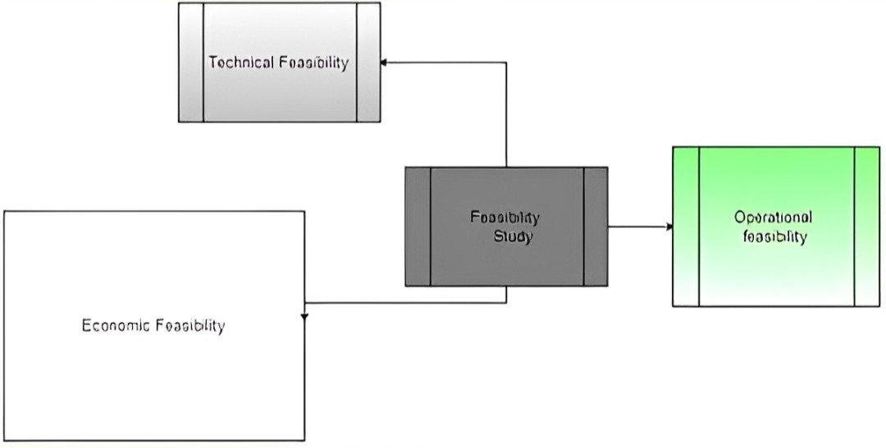

3.1.1 Technical Feasibility:
The technical feasibility assesses whether the necessary technology, skills, and resources are available to develop and deploy the system.
- Our application is being developed using Python for backend and desktop GUI (with Tkinter) [30], OpenCV for image capture and preprocessing [10], and YOLOv5, a state-of-the-art object detection algorithm, for real-time currency detection [14].
- We are also using text-to-speech and speech recognition modules for audio interaction, making the app accessible to visually impaired users [11].
- Google Colab Pro is being used as the primary training environment for our deep learning model due to its access to high-performance GPUs and faster execution time [22]. This cloud-based environment helps overcome the limitations of local hardware and allows us to train large datasets efficiently.

3.1.2 Economic Feasibility:
This evaluates the cost-effectiveness of the project.
- Most of the tools and libraries used in this project (like Python, OpenCV, Tkinter, PyTorch, etc.) are open-source and freely available [23].
- The only paid component is Google Colab Pro, which is used to speed up training and avoid GPU runtime limits. The subscription cost is minimal and justified by the convenience and improved training performance it offers.
- As the application runs on commonly available desktop systems and webcams, no specialized hardware is required, making the solution both affordable and scalable.
3.1.3 Operational Feasibility:
This assesses how well the proposed system solves the existing problems and fits into the intended environment.
- The proposed solution will directly aid visually impaired individuals in recognizing Pakistani currency without external assistance.
- The system is designed to be user-friendly, requiring only a simple voice command to trigger detection, and then announces the denomination audibly.
- By eliminating the need for expensive handheld or wearable hardware, and offering real-time detection through a desktop application, this system is practical and easy to operate in real-world scenarios.

3.2. Functional Requirements
These are the core features and behaviors the system must perform to meet the needs of visually impaired users for real-time currency detection:

3.2.1 Real-Time Currency Detection:
The application must allow capturing frames from the camera (either continuous video or single snapshot) for detection purposes.

3.2.2 Currency Detection Model:
The YOLOv5-based model should detect Pakistani currency notes in real-time with high accuracy using the trained custom dataset [14].

3.2.3 Text-to-Speech (TTS) Output:
Once currency is detected, the result must be announced via a text-to-speech engine to provide auditory feedback to the user.

3.2.4. Voice Command Integration:
The application should support basic offline voice commands (e.g., "Start, Stop") to make the interface more accessible for visually impaired users.

3.3. Non-Functional Requirements
These define the quality attributes and constraints of the system that ensure a smooth and reliable user experience:

3.3.1 High Accuracy and Precision:
The model must have high precision and recall rates to avoid false detections and misclassifications of currency notes.

3.3.2 Noise Tolerance:
The system should function effectively even under slight variations in lighting conditions, background clutter, or partially visible notes.

3.3.3 Real-Time Performance:
Detection and feedback (including TTS response) must occur within a few seconds to ensure responsiveness during real-world usage.

3.3.4 Lightweight and Efficient:
The system must be optimized to run efficiently on desktop systems without the need for high-end GPUs during inference.

3.3.5 User Accessibility:
The interface should be simple and minimalistic, designed with accessibility in mind, especially for visually impaired individuals.

3.4. System Requirements
First, we need to list everything required for our project, i.e., the programming language, IDE, dependencies involved as well as any form of hardware or literary material. It also includes application software and network facilities.

The following are some of the requirements of our project:

3.4.1 Computer/System
We need to have a proper computer system that has above average operational specifications to install and run the required software.

3.4.2 Internet Availability
We need a stable and fast internet connection to download required files and research for
information for the project. This is also required for communication between partners and correspondents.

3.4.3 GitHub Repository
We need a GitHub repository to download training materials, datasets, models, packages (dependences & files) etc.

3.4.4 Draw.io Software:
We use Draw.io to visualize our project from different aspects such as classes, activity, use case etc.

3.4.5 Microsoft Office
We use Microsoft Office for documenting different parts of the project. Such as thesis (MS Word), comparison charts (MS Excel) and Project Presentation (MS PowerPoint) etc.

3.4.6 Library
The library is the source of information for our project apart from the Internet.

3.4.7 Microsoft Visual Studio Code
This will be our primary IDE for coding and debugging our detection model.

3.4.8 Google Collaboratory
We will use python 3.9 as our interpreter and virtual environment.

3.4.9 YOLOv5
This will be our primary detection model which will be trained on our custom dataset [14].

3.4.10 Dataset
Our dataset contains at least eight different currency denominations. The population of datasets is average.

3.4.11 Text to Speech Engine
A text to speech engine will be linked to our application that will provide a voice output for the results of detection.

3.4.12 Basic Detection Model
The model we have trained for our project is based on an algorithm that has pretrained weights. We use the YOLOv5 model to train our custom dataset. The following diagram shows the working of a YOLOv5 model:

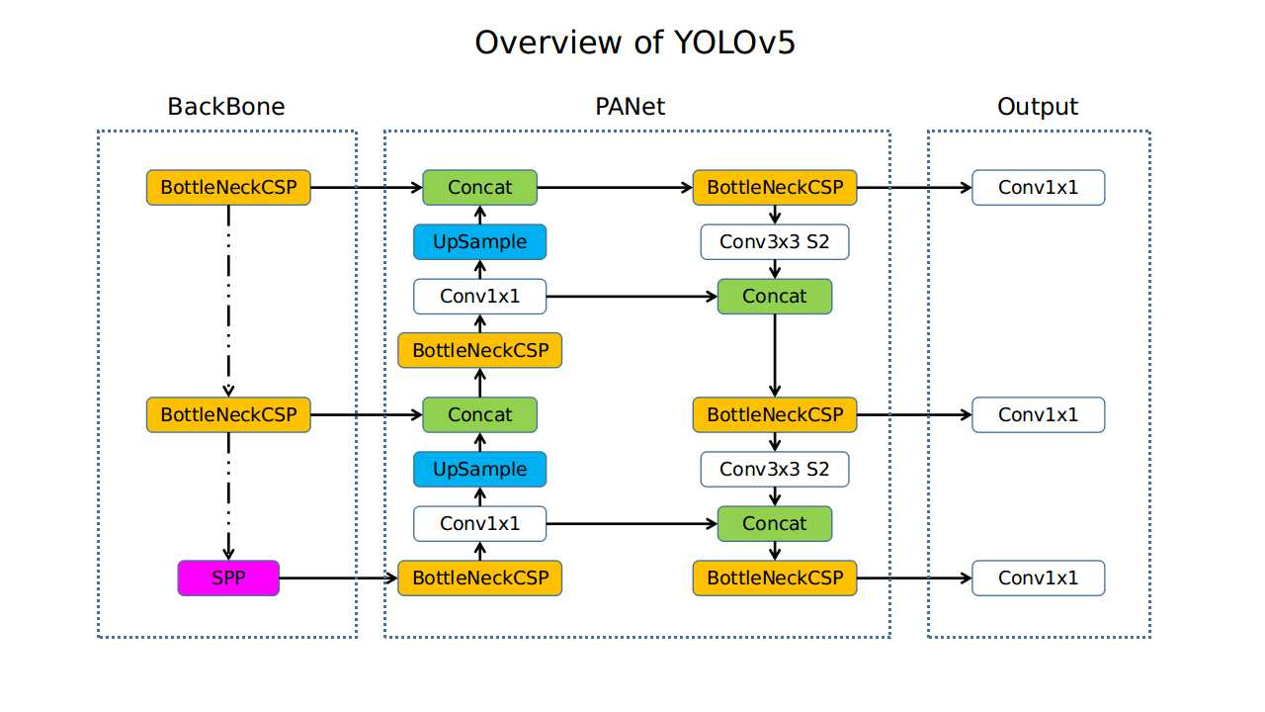
Figure 3.1: Basic Detection Model of YOLOv5
“It is a novel convolutional neural network (CNN) that detects objects in real-time with great accuracy. This approach uses a single neural network to process the entire picture, then separates it into parts and predicts bounding boxes and probabilities for each component. These bounding boxes are weighted by the expected probability. The method “just looks once” at the image in the sense that it makes predictions after only one forward propagation run through the neural network. It then delivers detected items after non-max suppression (which ensures that the object detection algorithm only identifies each object once.”
Its architecture mainly consisted of three parts, namely-
1. Backbone: Model Backbone is mostly used to extract key features from an input image.
2. Neck: The Model Neck is mostly used to create feature pyramids. Feature pyramids aid models in generalizing successfully when it comes to object scaling. It aids in the identification of the same object in various sizes and scales.
3. Head: The model Head is mostly responsible for the final detection step. It uses anchor boxes to construct final output vectors with class probabilities, abjectness scores, and bounding boxes.

3.5. Chosen Methodology

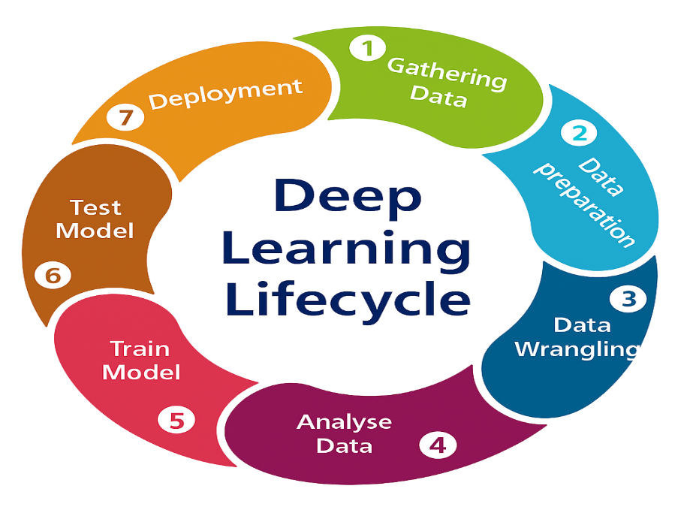
Figure 3.2: Deep Learning Life Cycle (DLLC)

The Deep Learning Life Cycle (DLLC) is a structured process for developing learning projects, starting with defining the problem and collecting relevant data [33]. The data is then cleaned, explored, and split into training, validation, and test sets. Model selection and training follow, where different algorithms are evaluated, and the best model is tuned through hyperparameter optimization.

3.6. Reason for Choosing DLLC
We have chosen the Deep Learning Life Cycle (DLLC) as the methodology for our project because it offers a structured and iterative approach to building robust Deep learning applications. Our currency detection project involves several essential DLLC stages such as data collection, preprocessing, model selection, training, evaluation, and deployment — all of which are core components of the DLLC framework. This methodology ensures that each step is addressed systematically, helping us to identify and resolve issues early in development while continuously improving model performance. Additionally, since our project involves both a Deep learning backend (YOLOv5 model training and evaluation) and deployment (in desktop application), DLLC fits well as it supports continuous integration and testing.

3.6.1 Advantages of DLLC
- Structured Development Process:
DLLC provides a clear, step-by-step roadmap from problem definition to deployment and maintenance, reducing confusion and development delays.
- Efficient Data Handling:
It emphasizes proper data collection, labeling, and preprocessing, which are critical to the performance of any DL model especially for real-time detection tasks like currency Detection.
- Improved Model Accuracy:
With iterative training and evaluation loops, the model can be fine-tuned for better precision and recall, leading to more accurate detection results.
- Flexibility and Scalability:
DLLC allows for easy adaptation to new requirements or updated datasets, ensuring that the system remains relevant and functional in the long term.
- Deployment Integration:
The methodology supports integration with real-world applications such as mobile and desktop platforms, which align perfectly with our project goals.
- Quality Assurance:
Regular testing and validation at each phase ensure that performance standards are met, and any degradation in accuracy is caught early.
- Team-Collaboration
By clearly defining responsibilities and workflows for each stage, it allows for smooth collaboration among team members working on data, modeling, Desktop Application development, and testing.

3.7 Use-Case Diagram

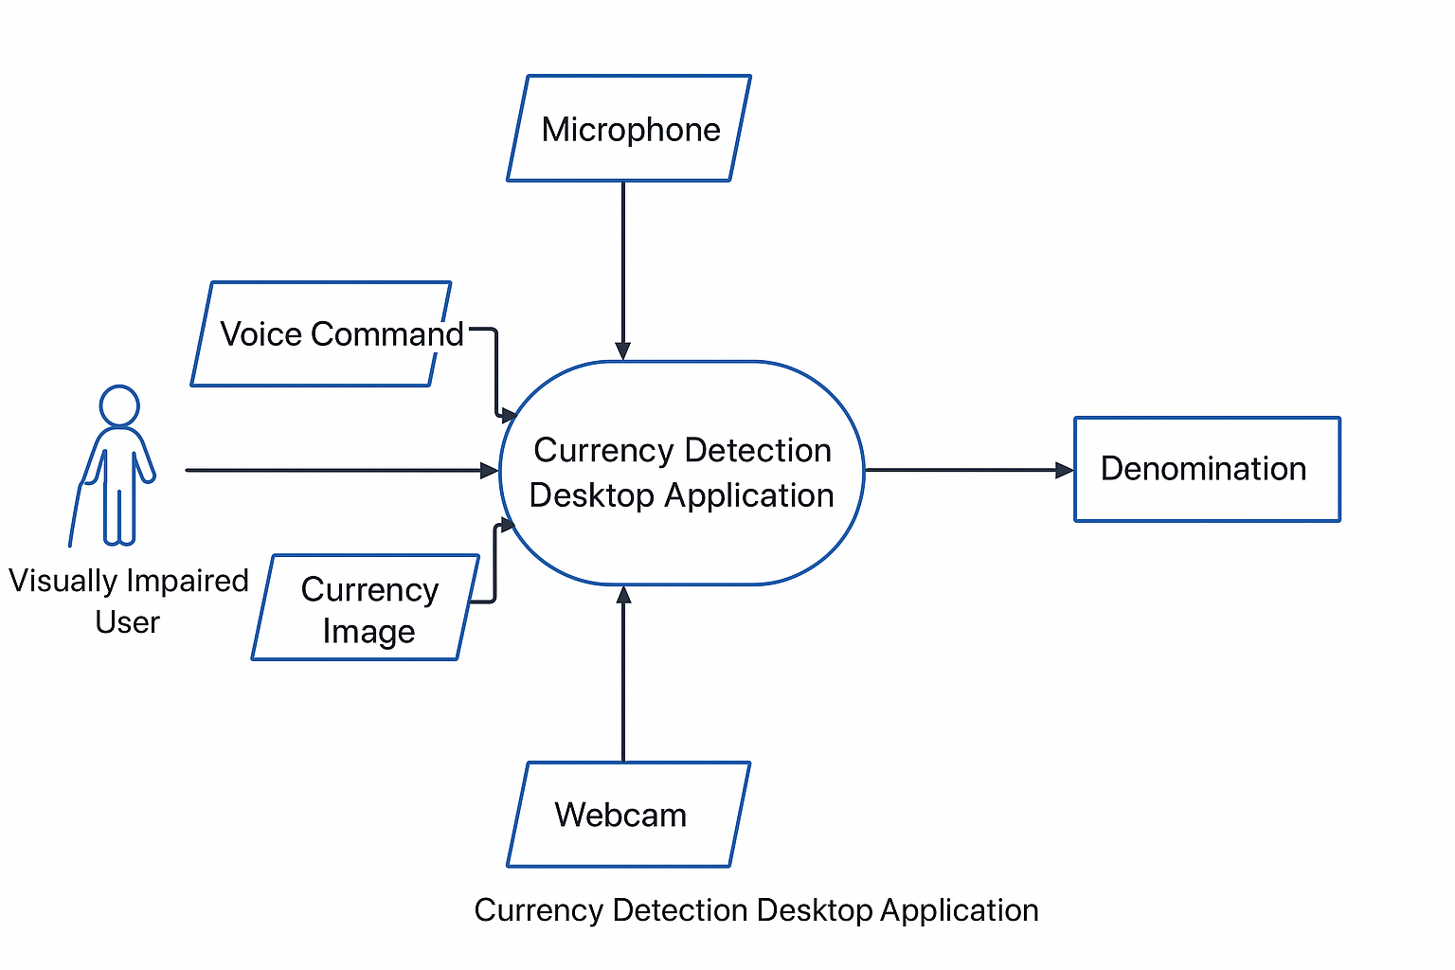

Figure 3.3: Use Case Diagram

3.8 Sequence Diagram

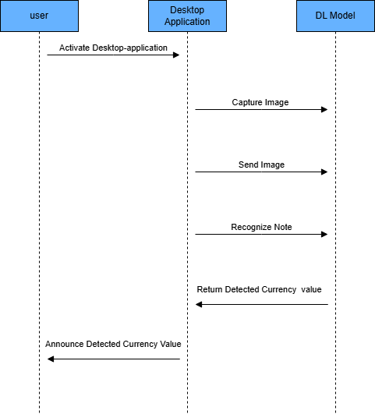

Figure 3.4: Sequence Diagram

3.9 Data Flow Diagram

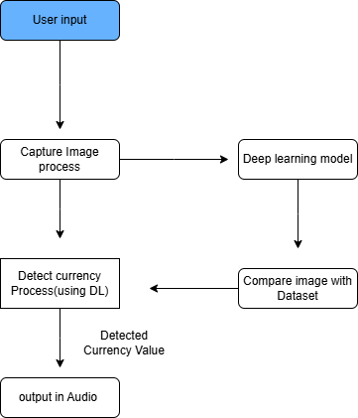

Figure 3.5: Data Flow Diagram

Chapter 4

System Implementation

4.1. Experimental Setup
We need to do is import and install some Software’s & dependencies for our project.

4.1.1 Python version:
We need to install the Python installer to be able to use the required libraries in our code [23].

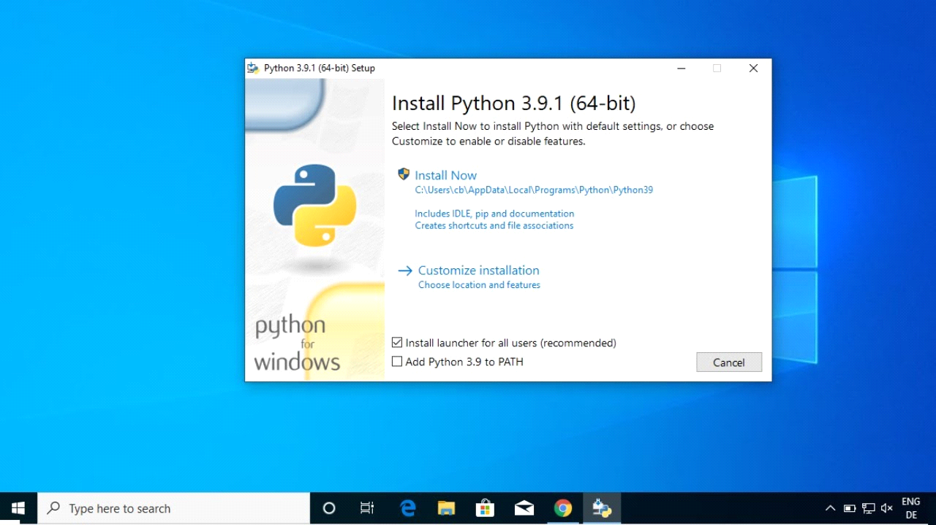
Figure 4.1: Installing Python
4.1.2 Visual-Studio Code:
The visual studio code will be our IDE to code our Desktop application (GUI).
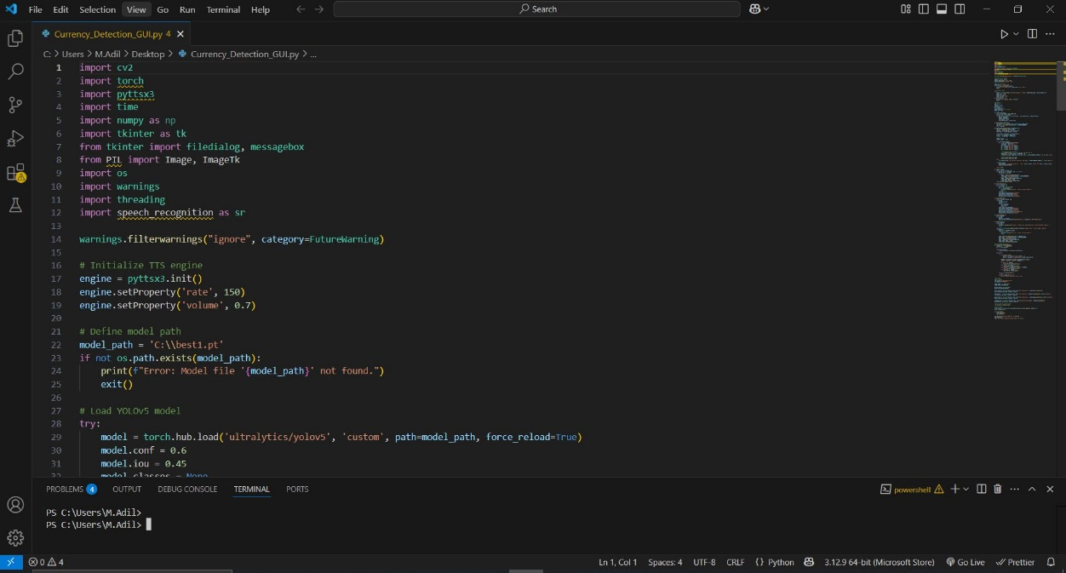
Figure 4.2: Environment of Visual-Studio Code

4.1.3 Draw.io:
We will use draw.io for creating different diagrams for our model
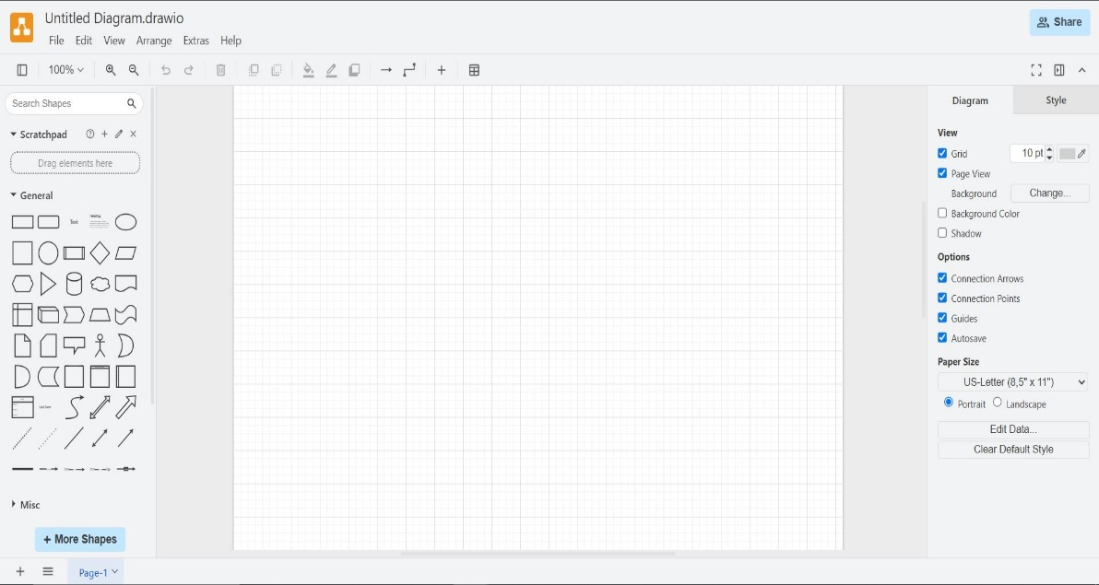
Figure 4.3: Working Environment of Draw.io

4.1.4 EndNote:
We will use EndNote to manage our references during the documentation of our project.
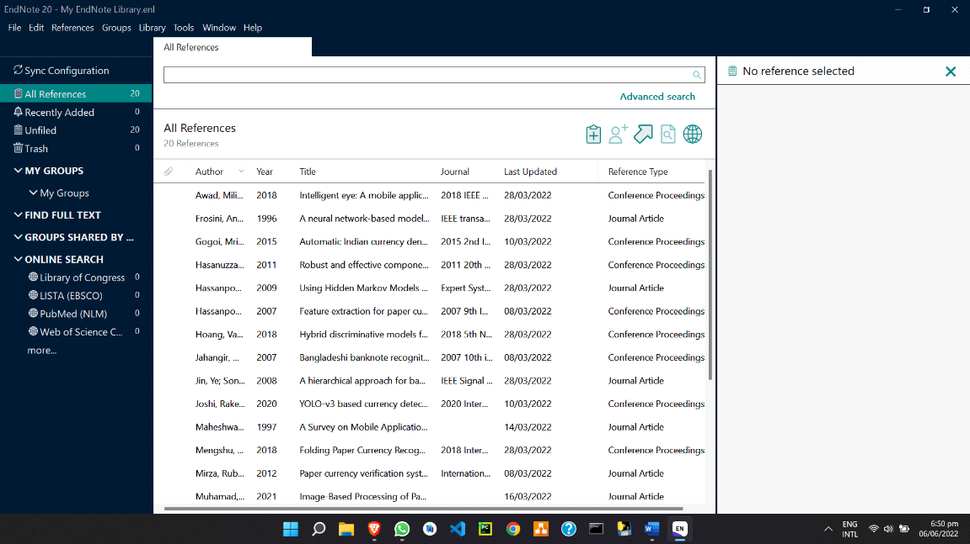
Figure 4.4: Environment of EndNote

4.1.5 Google Colaboratory:
Google Colab Pro is a cloud-based virtual platform that we used to train our model due to local GPU constraints. It provided access to enhanced GPU resources, allowing us to efficiently handle model training and large-scale data processing [22].
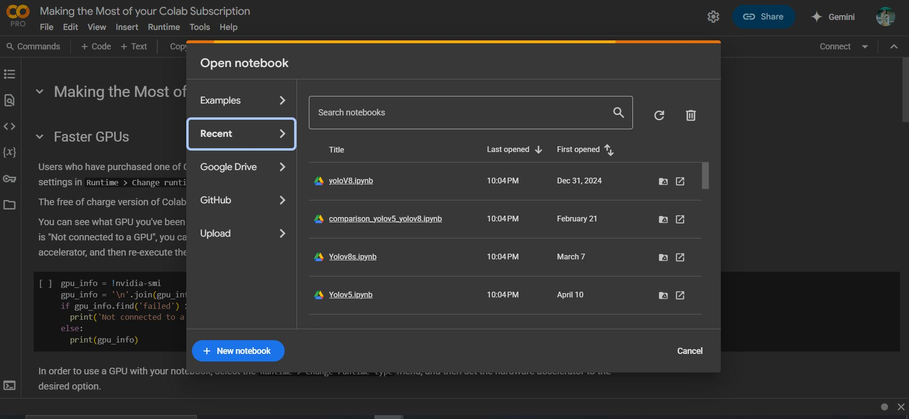
Figure 4.5: Environment of Google Colab

4.1.6 Microsoft Word:
We will use Microsoft Word to document each phase of our project and keep a standard format while documenting.
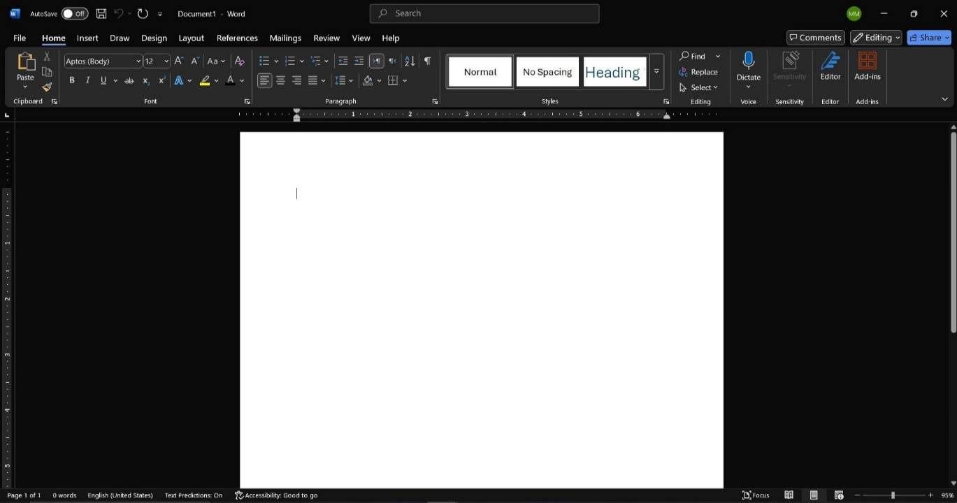
Figure 4.6: Working Environment of Microsoft Word

4.2. Implementation

4.2.1 Custom Detection Model Development:
Now that the prerequisites have been installed, we will start working on building our detection model. For that first we need to make the dataset first.

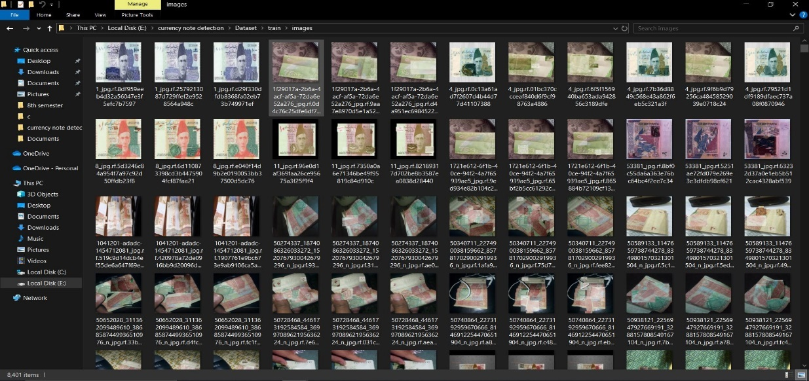
Figure 4.7: Taning Dataset

4.2.2 Training Yolov5 Model:
To train our model with Yolov5 framework we download its repository in our computer from GitHub [14].

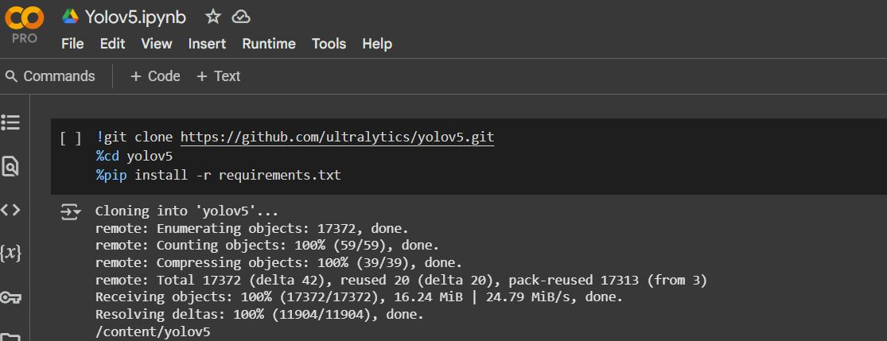
Figure 4.8: GitHub Repository of YOLOv5
After cloning yolov5, we will start writing the code for our data.yml file. This is an important file required for the training of our model.

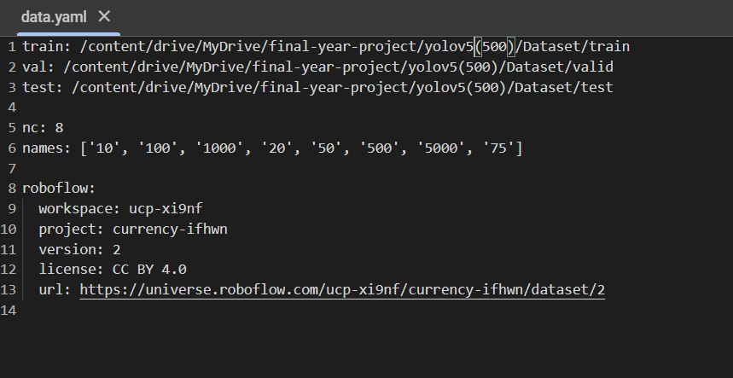
Figure 4.9: YAML File for Class Labels in Dataset

Next, we start training our model using the following script in google colab:

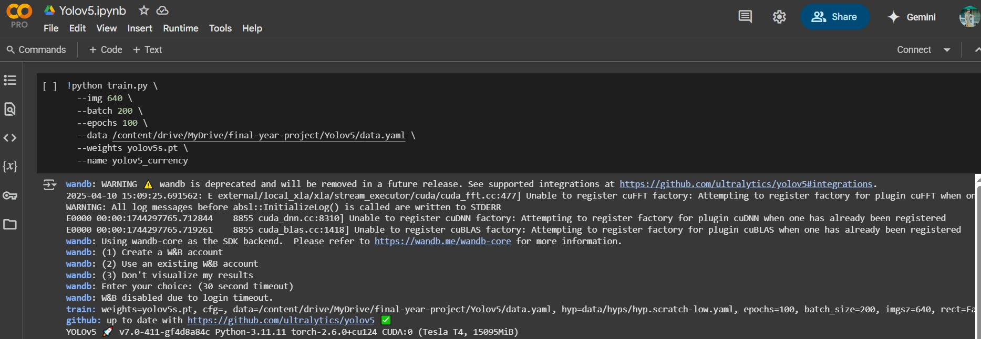

Figure 4.10: Script for Training YOLOV5 Model in Google Colab

Under this script the train.py file will run while accepting the subsequent arguments as parameters for our model. The weights file yolov5s.pt is the pretrained yolov5s weights which will be changed to create new weight files for inference. The training will take a bit of time to complete.
The training process will look like this:

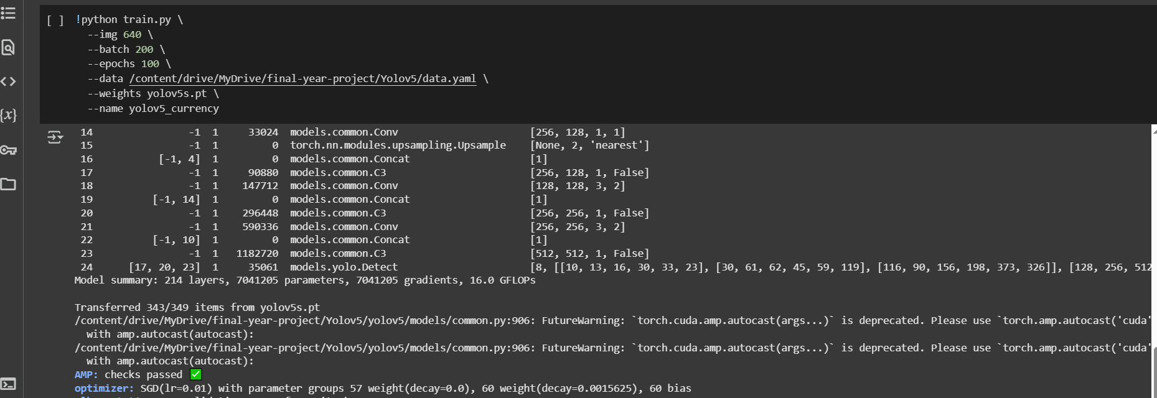
Figure 4.11: Training Process in Google Colab

After the training is completed the train directory will have an experiment folder exp folder that contains the results of the current training. It contains several files as well as weight file.

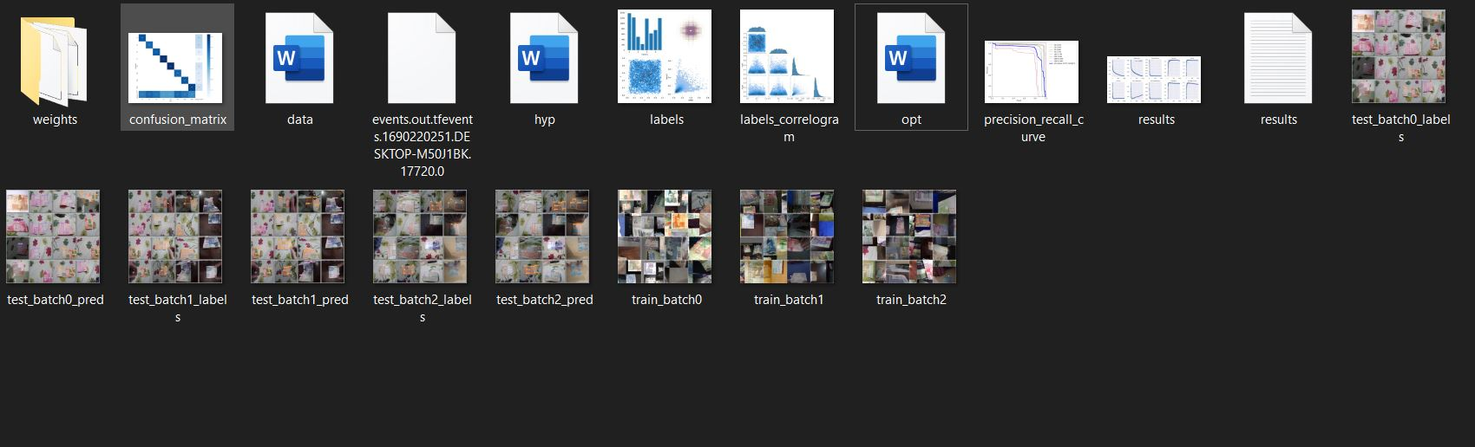
Figure 4.12: Results in /train Directory
Finally, the model is trained, and weights are generated.

4.3 Desktop Application development:

4.3.1 Creating GUI:
For our Deep learning project, we have created the GUI using python library [21]
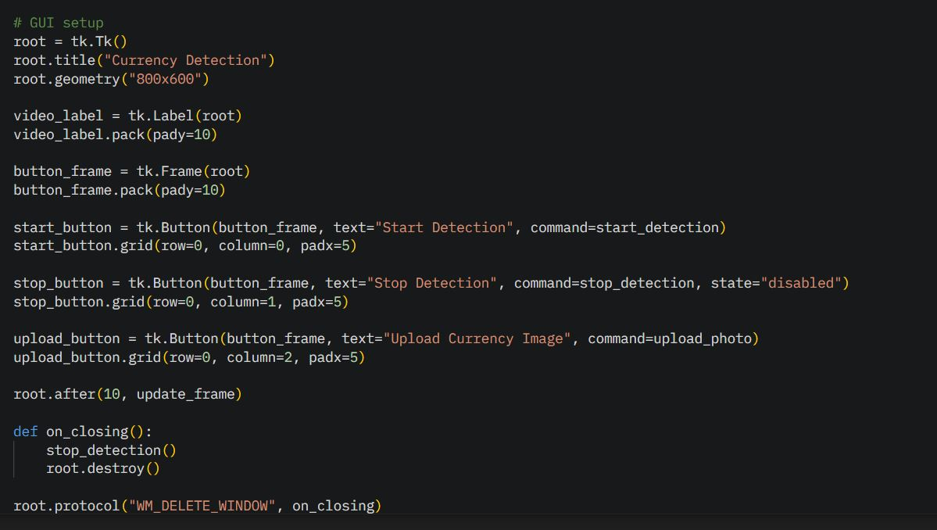
Figure 4.13: Creating the GUI using TKinter

4.3.2 Coding Voice Output Modu2e:
The output of our model after detection is audio-based to assist the blind. For that reason, we have included a module to process the results of detection to voice output in our desktop application.
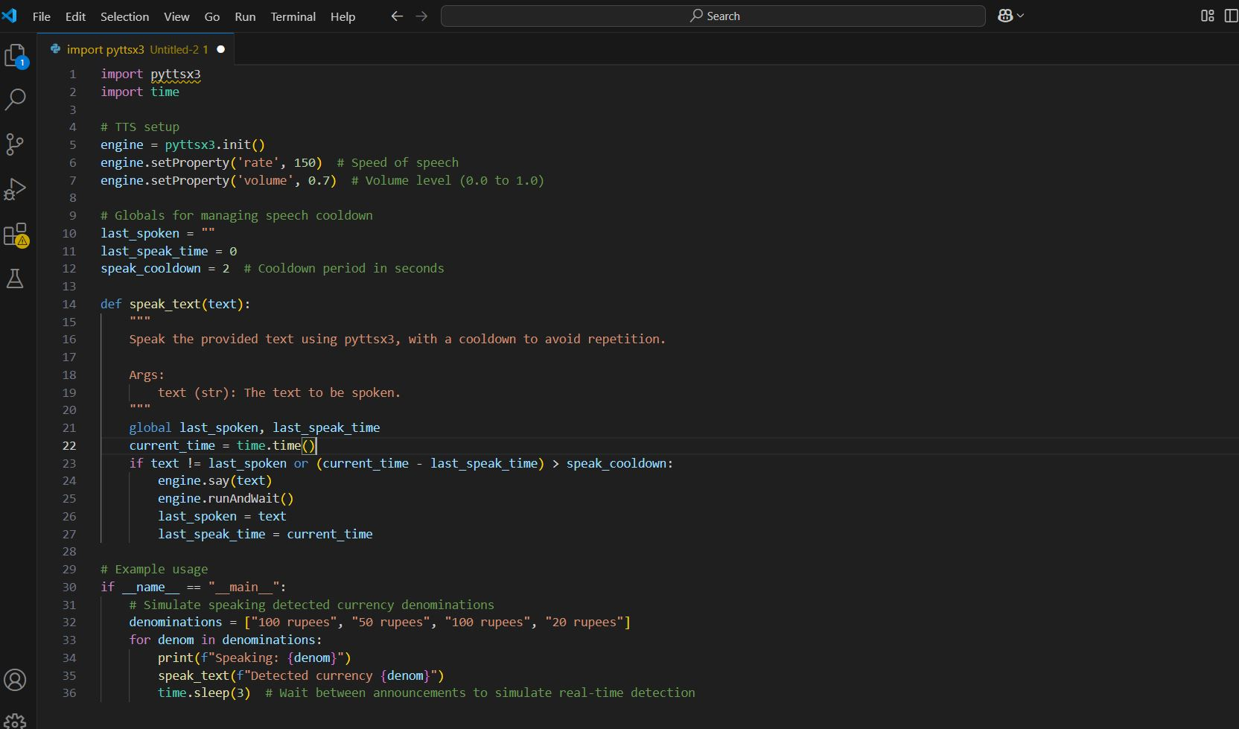
Figure 4.14: Code for TTS module in python

4.3.3 Integrating the Speech-Recognition Module:
In this project, Vosk was utilized to enable voice-based control (e.g., "start" and "stop") for the currency detection application [11], ensuring accessibility for visually impaired users without requiring an internet connection.
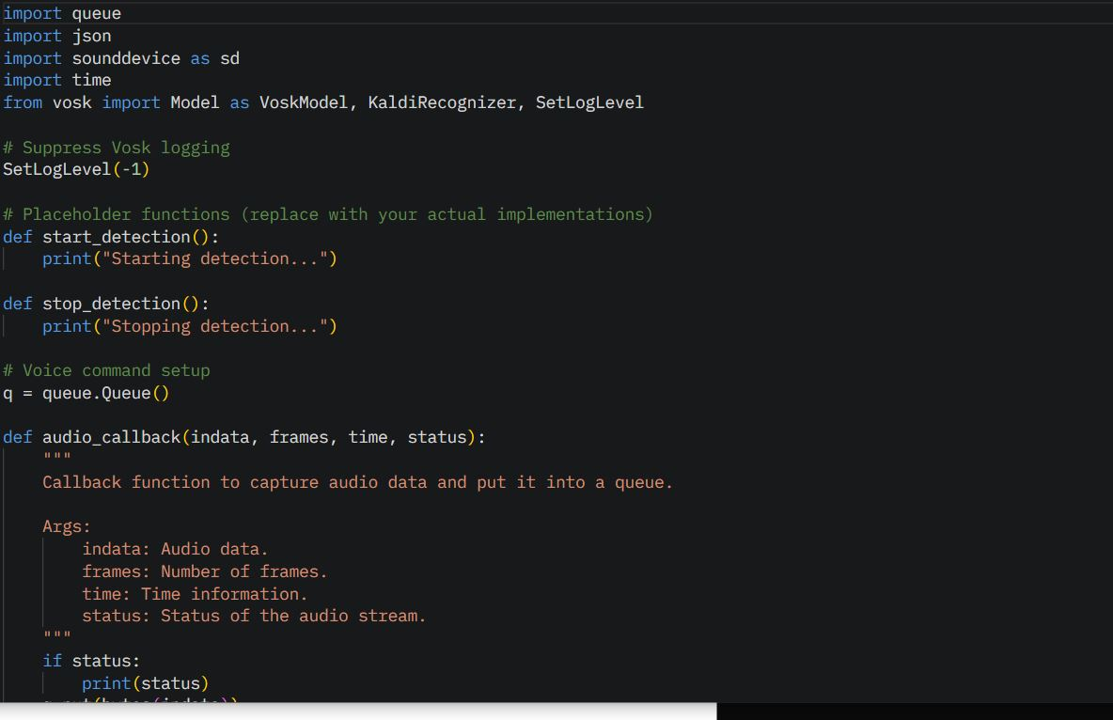
Figure 4.15: Integrating Speech-Recognition Module

Chapter 5

Evaluation and Results

5.1. Testing and Validating Model:
In this section, we will test our model from different aspects and generate several results which can be used to evaluate the performance of the model.

5.1.1 Testing Model:
We will test our model using two different ways:
- Using python code in Google colab.
- Using Desktop-application for real-Time detection.
We will test our model on two different inputs:
- Image from directory.
- Image captured in real-time using laptop webcam.

Below are some figures demonstrating the testing through different means:

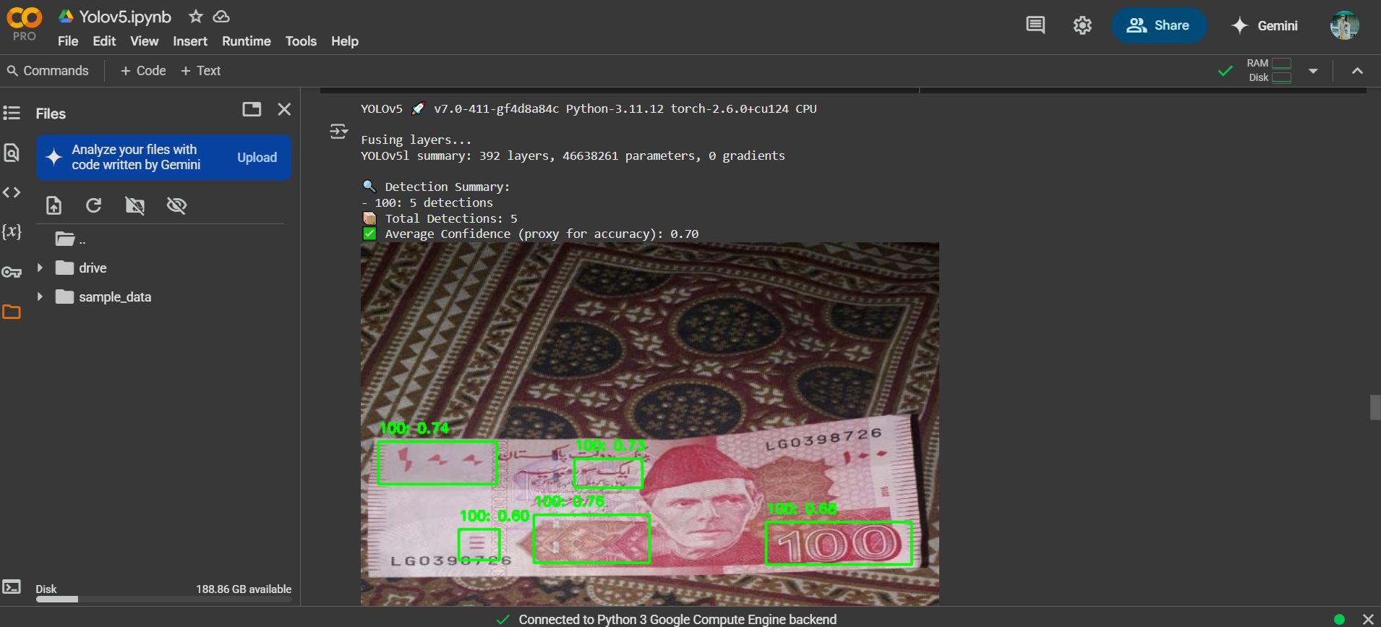
Figure 5.1: Model Testing using Google colaboratory

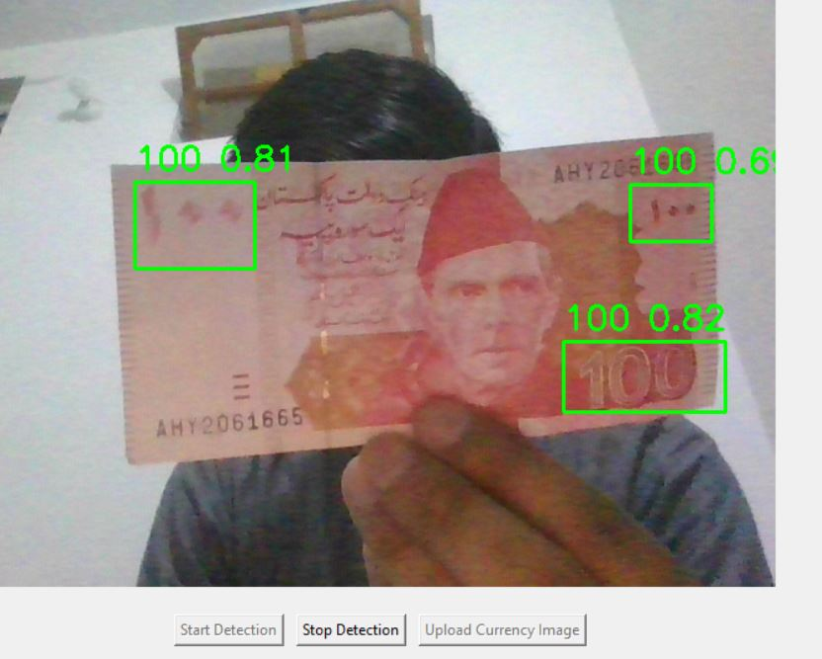
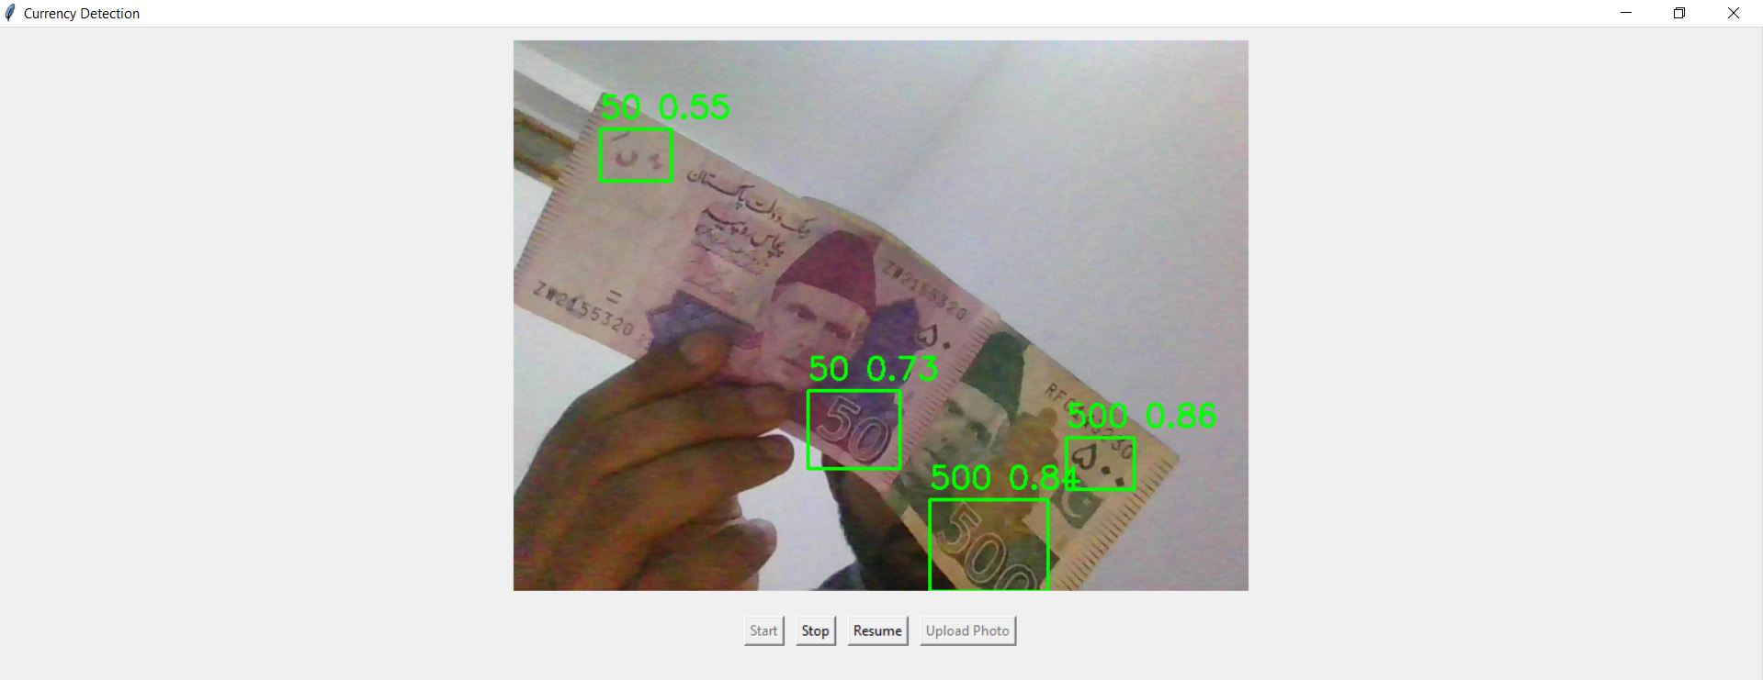
Figure 5.2: Real-Time Currency Detection Using Laptop Webcam

5.1.2 Validating model:
The training dataset will be divided into 70% for training and 30% for validating.
This section shows the training and validation results of our model:

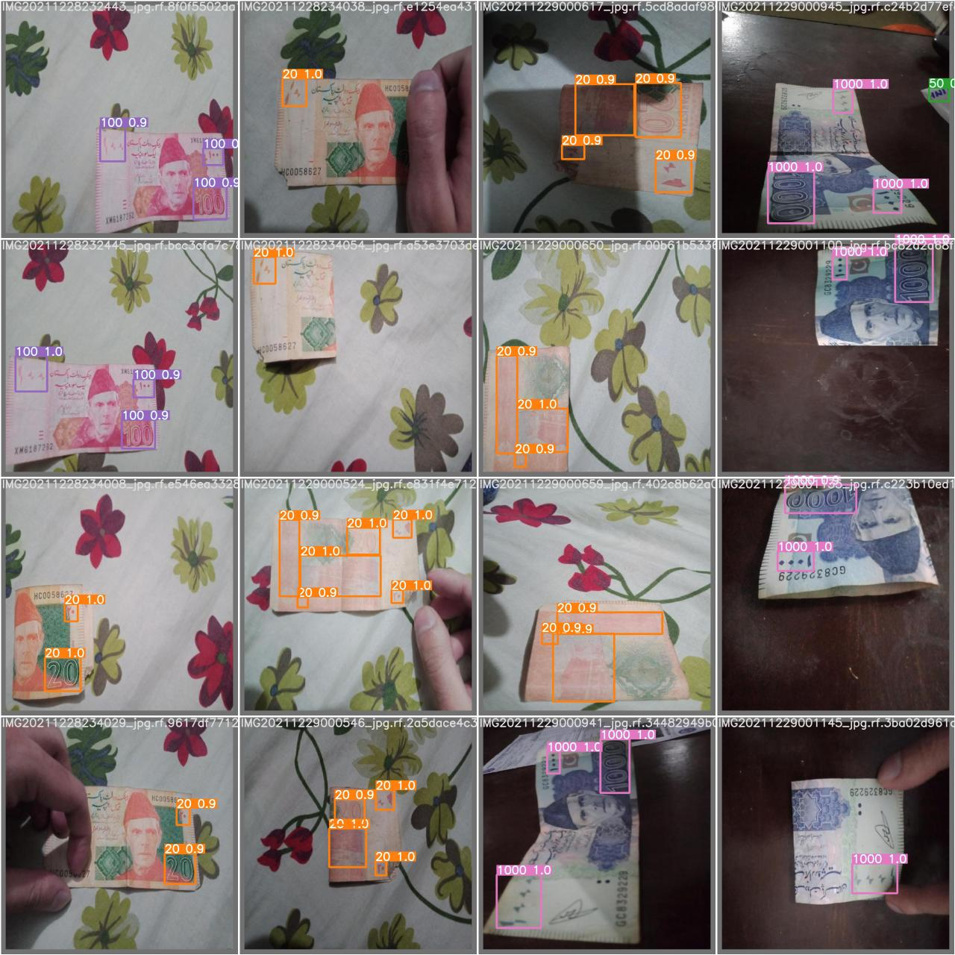

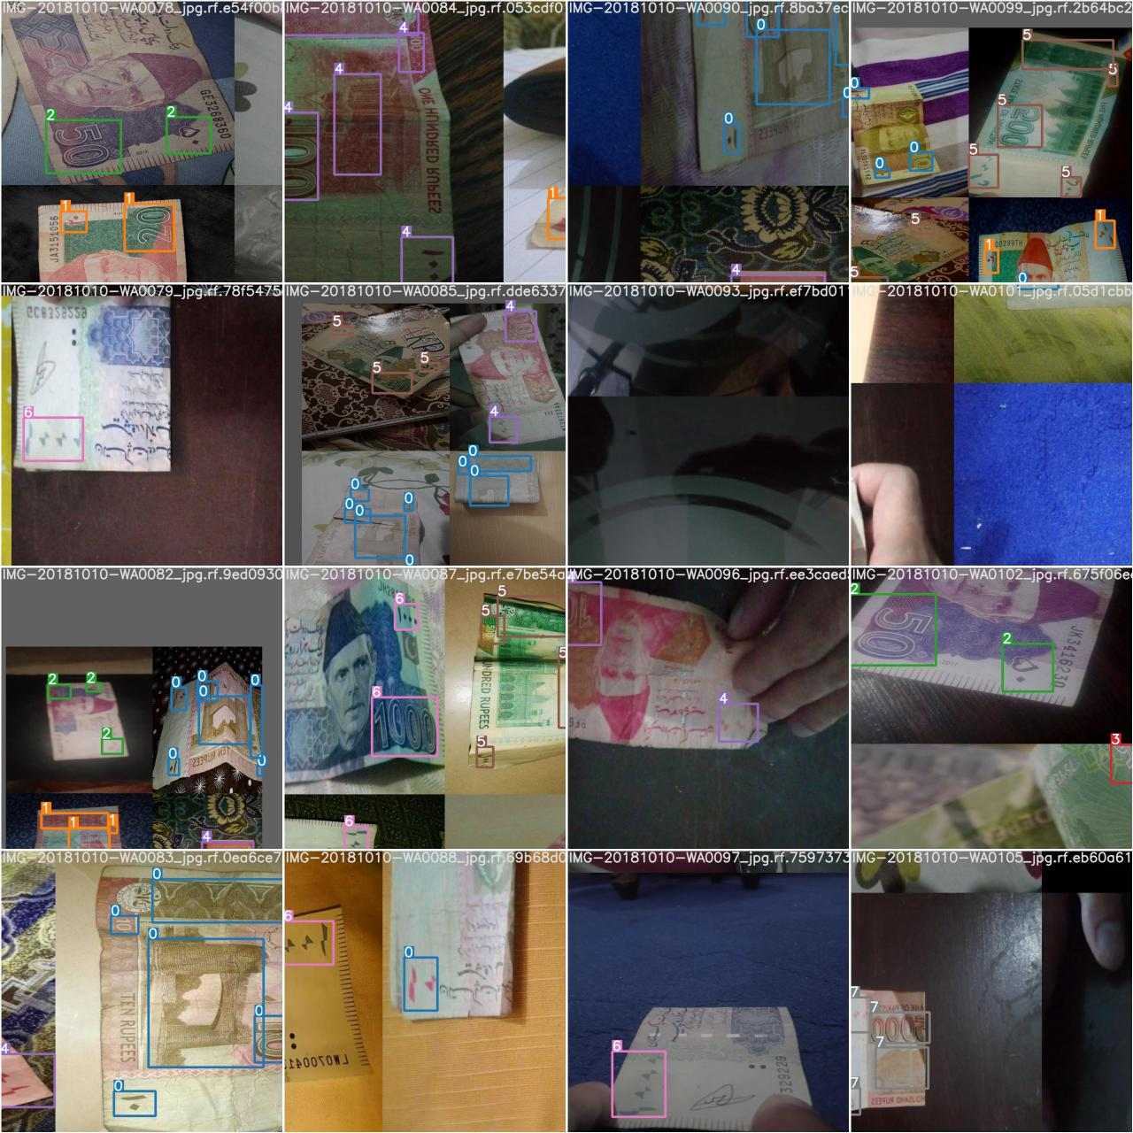
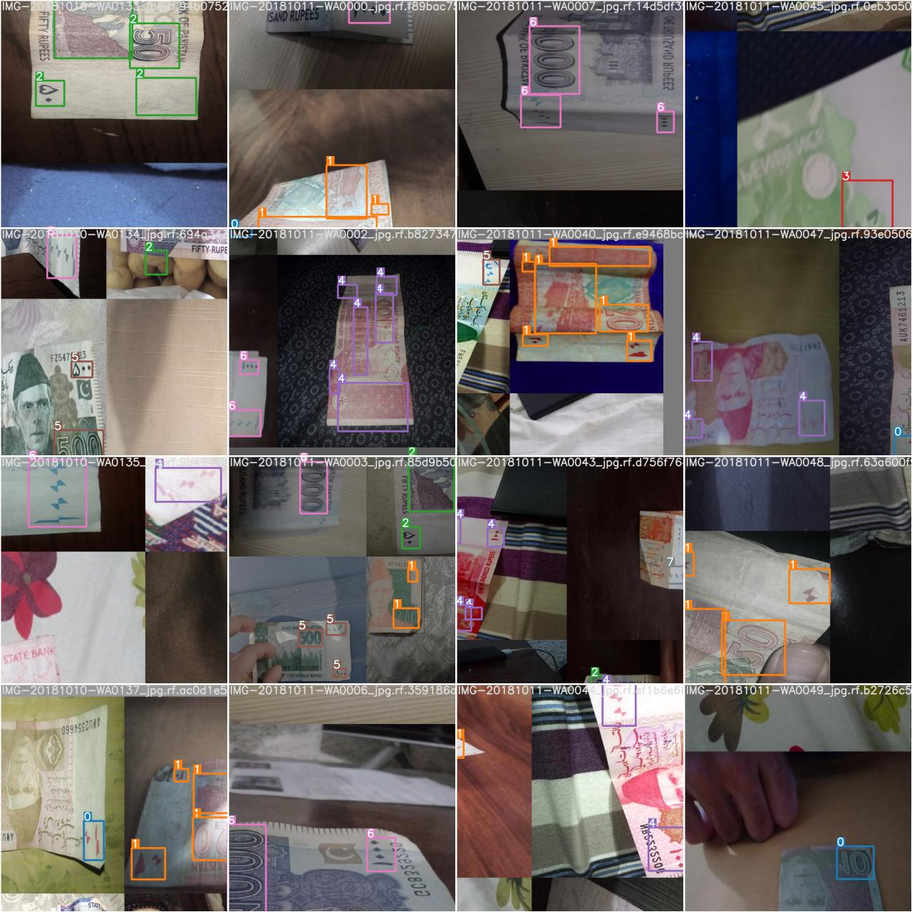
Figure 5.3: Validation Batch Results

5.1.3 Evaluation Metrics:
In the next section we will evaluate our model based on some metrics.
- PR-Curve
It is a graph of precision vs recall.

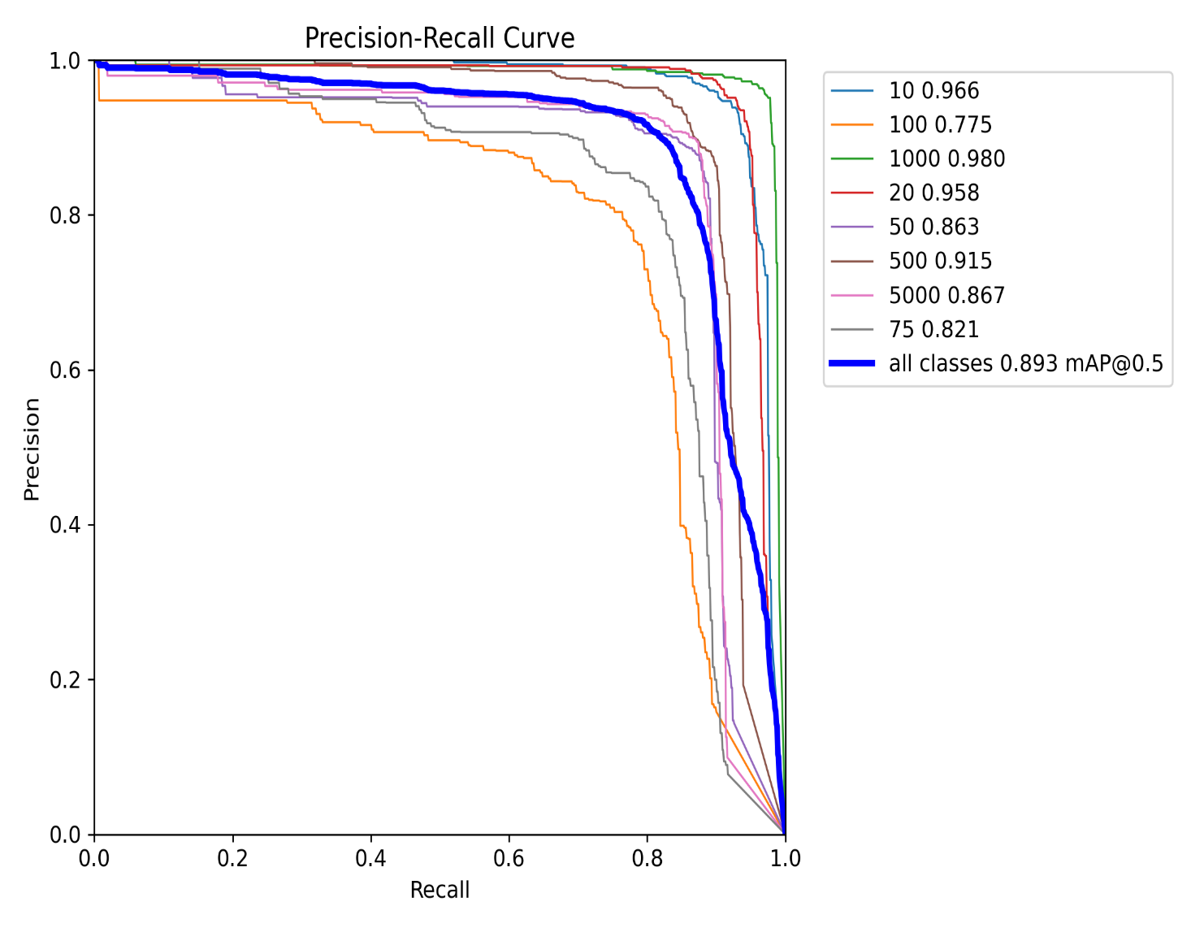

Figure 5.4: PR Curve

- PC-Curve
It is a graph of precision vs confidence.

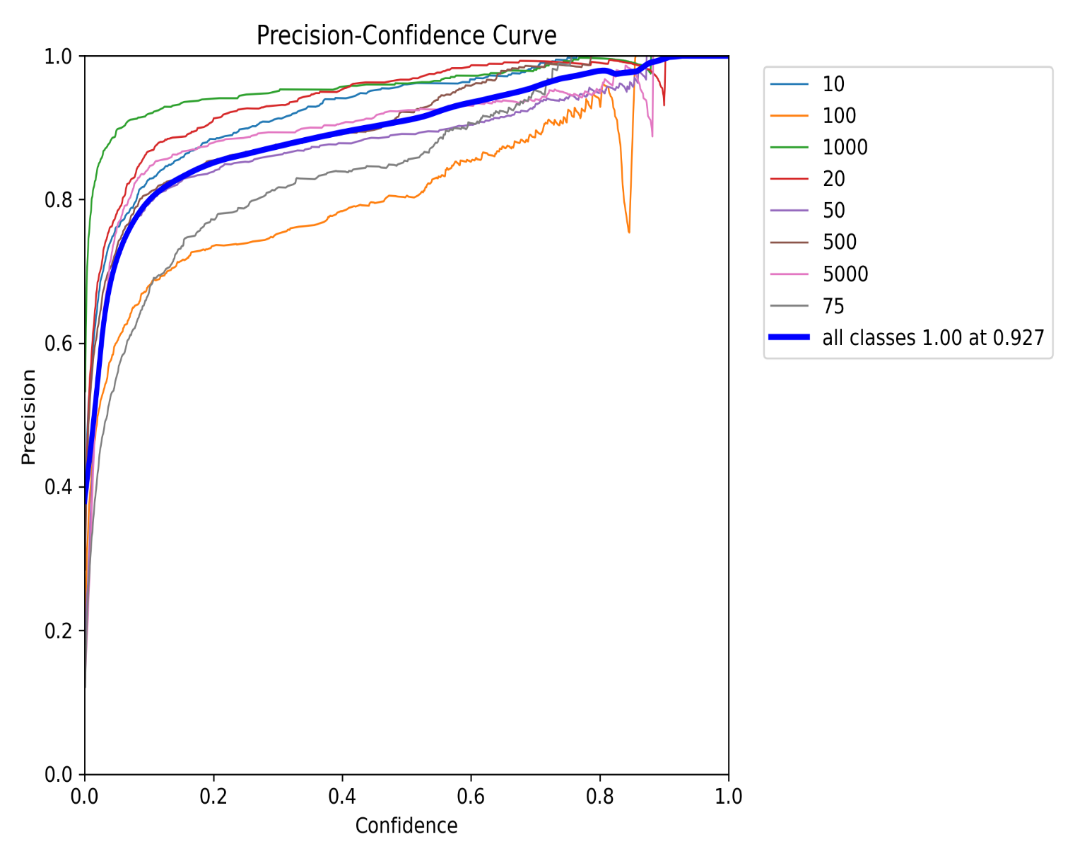

Figure 5.5: PC Curve

- F1-Score and Confidence Curve
It is a graph of F1-Score vs Confidence.

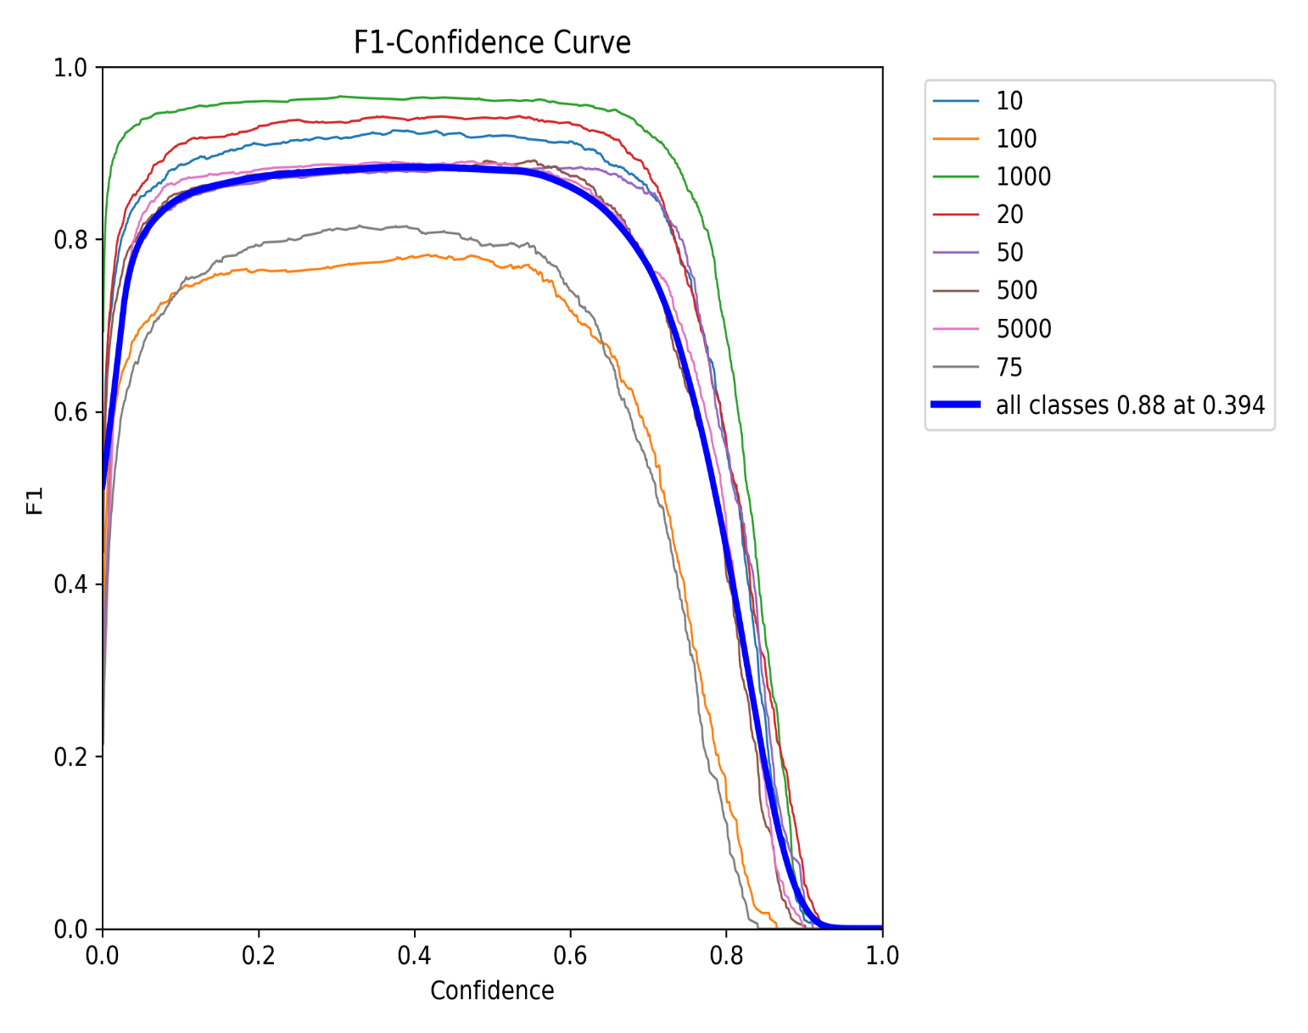

Figure 5.6: F1-Score and Confidence Curve

- Confusion Matrix
It is a graph of Confusion Matrix of my deep learning model.

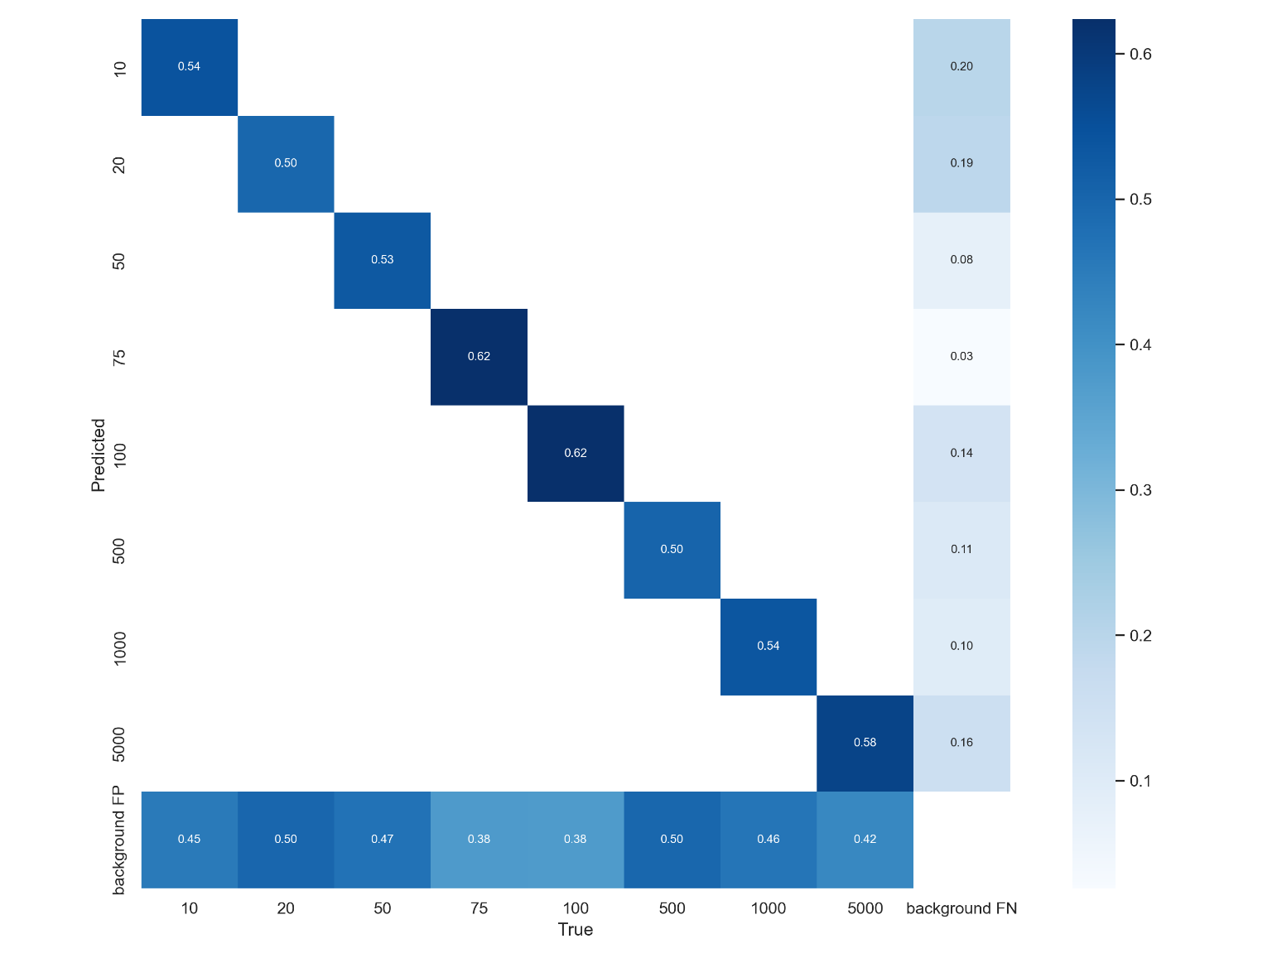

Figure 5.7: Confusion Matrix

- Result Graph
The graph below is compound representation of different parameters during the training of our model.

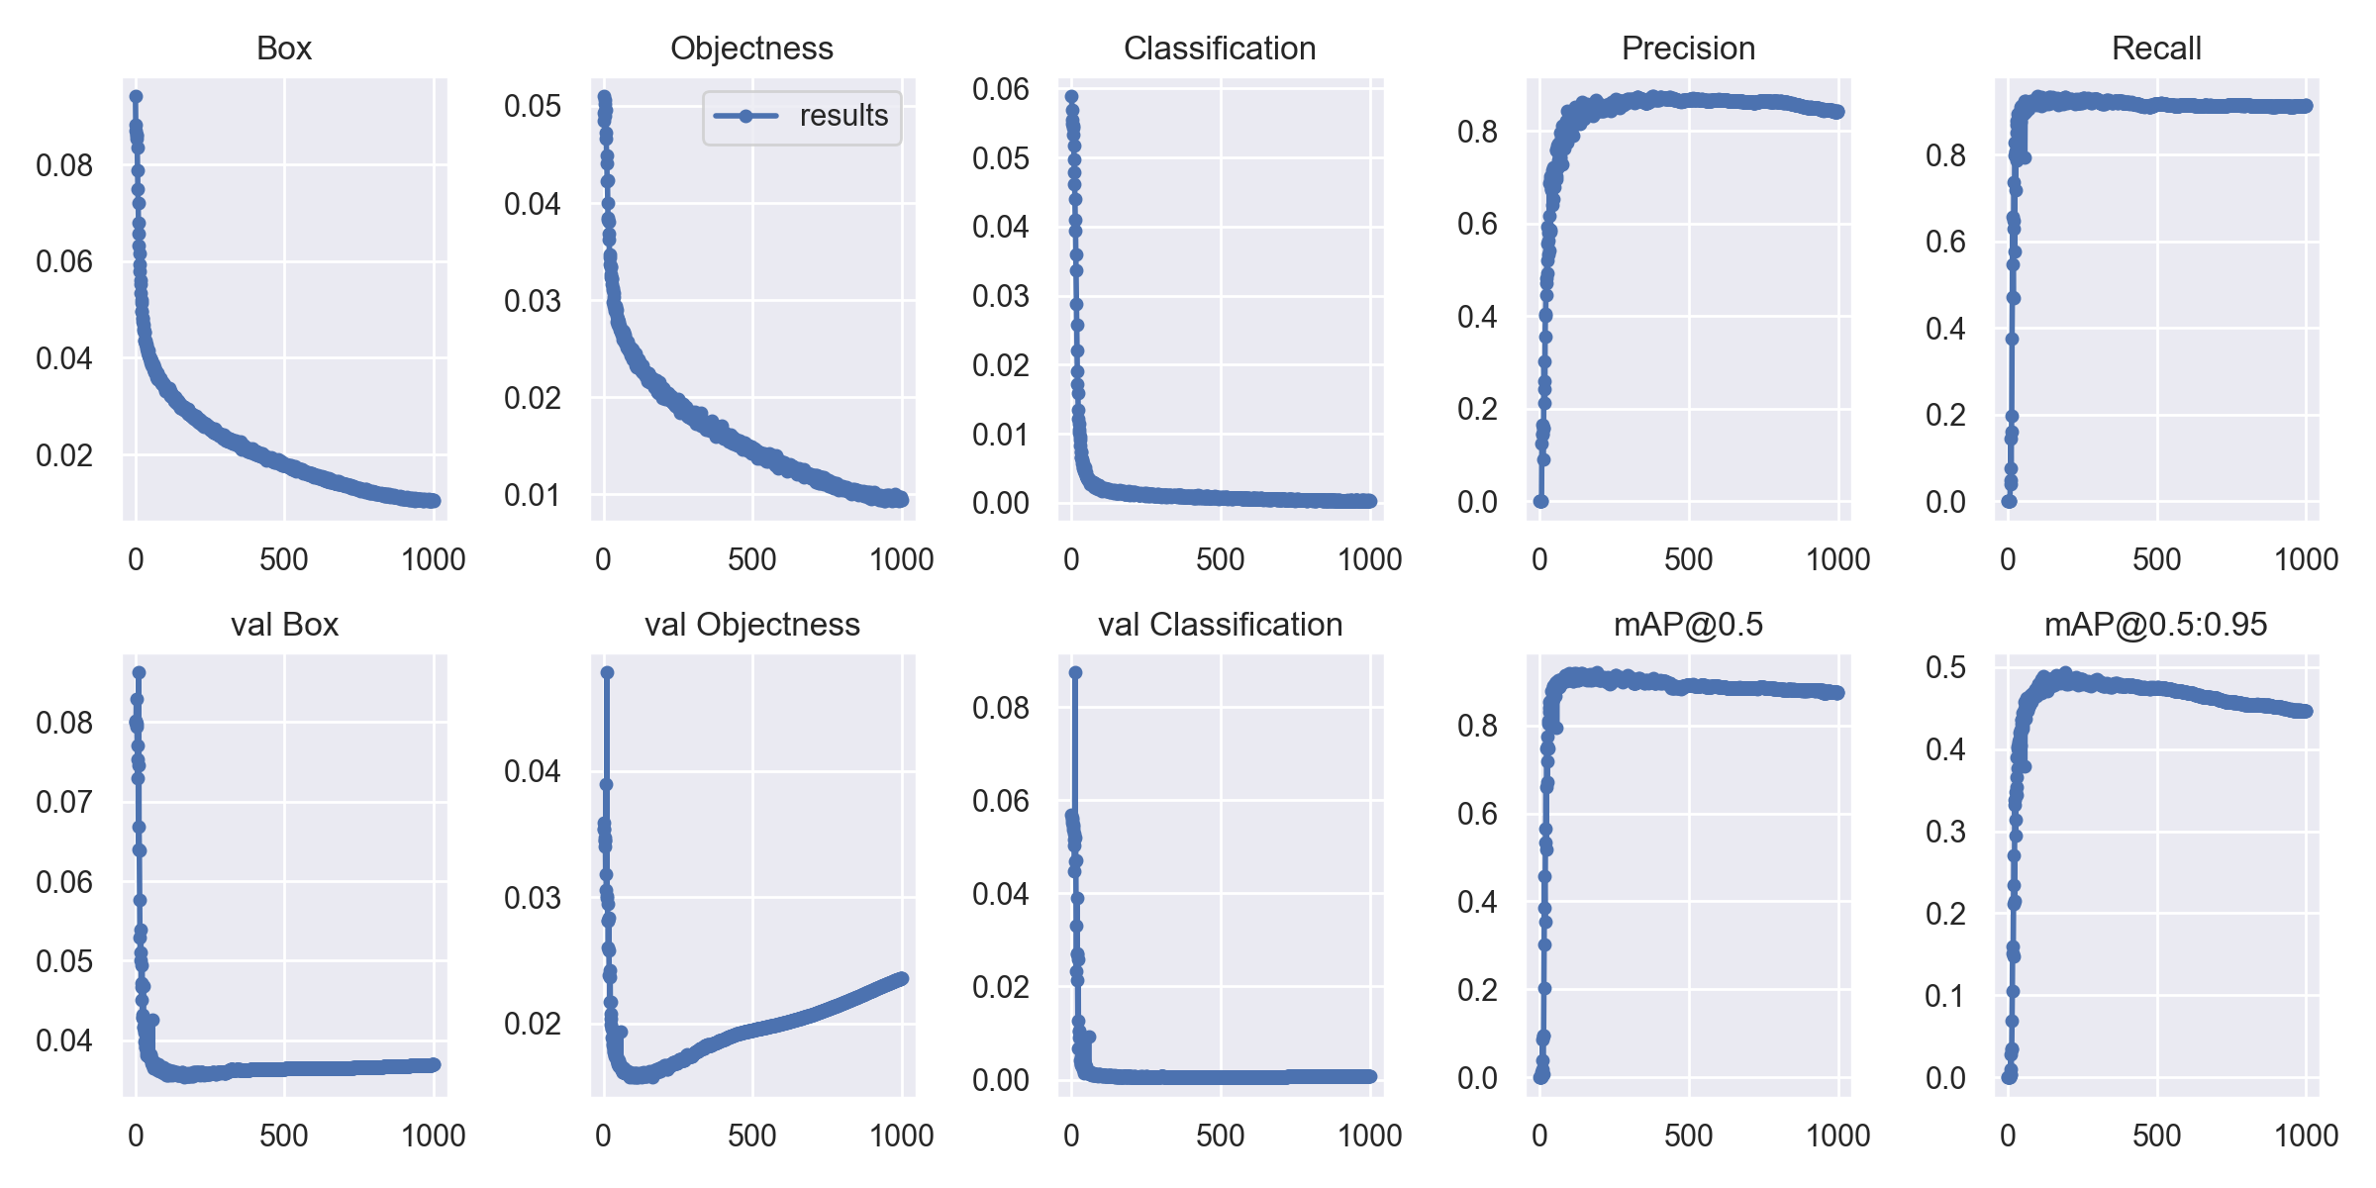

Figure 5.8: Result Graph

Chapter 5

Conclusion and Future Work

5.1 Conclusion
Based on our evaluation and results, we conclude that our project, aimed at creating a currency detection system for blind assistance using deep learning, has produced promising outcomes and successfully achieved the objectives set for this project. A custom-trained YOLOv5 model for Pakistani currency detection has been developed, along with a compiled and labeled dataset.
The evaluation results demonstrate that the accuracy and reliability of the deep learning model are quite high. The model is capable of processing real-time image inputs and providing accurate detection results, making it highly suitable for applications designed to assist visually impaired users.

5.2 Future Work
The future potential of this project is extensive, offering several opportunities for further development and enhancement. In the future, the trained deep learning model can be adapted and deployed into mobile applications, improving accessibility for visually impaired users. Additionally, the model can be extended to recognize multiple currencies beyond Pakistani notes, including the detection of various denominations and coins. Further research can also explore the possibility of training the model to differentiate between genuine and counterfeit currency based on graphical and texture features. Expanding compatibility to platforms like iOS could also broaden the scope and usability of the system.

REFERENCES

[1] World Health Organization, "World report on vision," WHO, Geneva, Switzerland, 2019. [Online]. Available: https://www.who.int/publications/i/item/world-report-on-vision.
[2] R. R. A. Bourne et al., "Vision loss expert group: Global causes of blindness and distance vision impairment 1990–2020," Lancet Global Health, vol. 9, no. 2, pp. e130–e143, 2021.
[3] J. M. Loomis, R. G. Golledge, and R. L. Klatzky, "Navigation system for the blind: Auditory display modes and guidance," Presence: Teleoperators and Virtual Environments, vol. 7, no. 2, pp. 193–203, 1998.
[4] A. M. Hassan and S. M. Elghamry, "Assistive technologies for visually impaired: A comprehensive review," IEEE Access, vol. 8, pp. 123456–123467, 2020.
[5] M. A. Khan, "Challenges in currency recognition for the visually impaired," J. Accessibility Studies, vol. 12, no. 3, pp. 45–56, 2019.
[6] R. C. Gonzalez and R. E. Woods, Digital Image Processing, 4th ed. Pearson, 2018.
[7] A. Krizhevsky, I. Sutskever, and G. E. Hinton, "ImageNet classification with deep convolutional neural networks," in Proc. Adv. Neural Inf. Process. Syst., 2012, pp. 1097–1105.
[8] Y. LeCun, Y. Bengio, and G. Hinton, "Deep learning," Nature, vol. 521, no. 7553, pp. 436–444, 2015.
[9] J. Redmon et al., "You Only Look Once: Unified, real-time object detection," in Proc. IEEE Conf. Comput. Vis. Pattern Recognit., 2016, pp. 779–788.
[10] G. Bradski, "The OpenCV library," Dr. Dobb’s J. Softw. Tools, vol. 25, no. 11, pp. 120–125, 2000.
[11] Vosk, "Vosk: Offline speech recognition API," 2021. [Online]. Available: https://alphacephei.com/vosk/.
[12] S. K. Jain and R. K. Sharma, "A survey on assistive devices for visually impaired," IEEE Trans. Human-Mach. Syst., vol. 50, no. 4, pp. 345–356, 2020.
[13] M. S. Ali and A. H. Khan, "Cost analysis of wearable assistive devices," in Proc. IEEE Int. Conf. Access. Technol., 2021, pp. 1–6.
[14] J. Glenn, "YOLOv5: A real-time object detection framework," GitHub, 2020. [Online]. Available: https://github.com/ultralytics/yolov5.
[15] P. Kumar and S. L. Shimi, "Currency recognition systems: A literature review," IEEE Trans. Image Process., vol. 29, pp. 2345–2356, 2020.
[16] A. R. Smith, "Field study on currency handling by visually impaired," J. Vis. Impairment Blindness, vol. 114, no. 2, pp. 89–100, 2020.
[17] L. Chen and T. Wu, "User experience in assistive technology: Interviews with visually impaired," in Proc. IEEE Int. Conf. Human-Comput. Interaction, 2021, pp. 1–7.
[18] R. T. Patel and M. J. Desai, "Survey on assistive tools for the blind," IEEE Trans. Access. Technol., vol. 12, no. 1, pp. 56–67, 2019.
[19] V. K. Sharma and U. S. Pandey, "Color-based Indian currency detection using neural networks," in Proc. IEEE Int. Conf. Signal Process., 2018, pp. 123–128.
[20] H. Lee and J. Kim, "Feature-based currency recognition using histograms," IEEE Trans. Pattern Anal. Mach. Intell., vol. 40, no. 5, pp. 1123–1135, 2018.
[30] Python Software Foundation, "Tkinter: Python interface to Tcl/Tk," 2021. [Online]. Available: https://docs.python.org/3/library/tkinter.html.
[31] Google, "Google Colaboratory: Cloud-based Jupyter notebook environment," 2020. [Online]. Available: https://colab.research.google.com/.
[32] Python Software Foundation, "Python programming language," 2021. [Online]. Available: https://www.python.org/.

